FINAL REPORT: JKUAT TEAM IN WHO NETWORK OF PARTNERS
SRHR Health Workforce Modelling Initiative for WHO AFRO Region
Date: 30th April, 2026

Contents
List of Tables iii
List of Figures iv
EXECUTIVE SUMMARY v
1.0 INTRODUCTION AND PROJECT BACKGROUND 1
1.1 The SRHR Workforce Challenge in Africa 1
1.2 WHO AFRO Pillar 2: Enhancing Health Workforce Development for SRHR 1
1.3 Objectives for JKUAT Team 1
1.4 Project Progress Overview 2
2.0 CONTEXTUAL ANALYSIS OF SRHR WORKFORCE CHALLENGES IN AFRICA 3
Regional Overview: The African SRHR Workforce Landscape 3
3.0 METHODOLOGICAL FRAMEWORK 7
3.1 Overview of Integrated Modelling Approach 7
3.2 The 14 Integrated Modelling Approaches 7
3.2.1 Stock-and-Flow Models for Supply Projection 7
3.2.2 Needs-Based Demand Estimation Models 8
3.2.3 Workforce Gap Analysis Models 8
3.2.4 Optimization Models for Resource Allocation 9
3.2.5 System Dynamics Models 9
3.2.6 Agent-Based Models (ABM) 10
3.2.7 Microsimulation Models 10
3.2.8 Cohort-Based Simulation 11
3.2.9 Skill-Mix Optimization Models 11
3.2.10 Stochastic Models for Uncertainty Analysis 12
3.2.11 Econometric Models for Causal Inference 12
3.2.12 Time-Series Models for Trend Analysis 13
3.2.13 Workload Indicators of Staffing Need (WISN) Methodology for Workload-Based Staffing 13
3.2.14 Manpower Planning Models 14
3.3 Integration Framework 14
3.4 Structural Equation Modelling (SEM) Framework 15
3.5 Modern Portfolio Theory (MPT) Application 15
3.6 Data Requirements and Sources 16
4.0 RESULTS AND FINDINGS 18
Study 1: Health Workforce and Financing Dynamics – Fixed Effects Panel Analysis of Life Expectancy and Universal Health Coverage 18
Study 2: Investing in Health Systems - Insights into How Current Health Financing Allocations Shape UHC Service Coverage and Key Health Outcomes 24
Study 3: Investing in Health Systems – Insights into How Health Financing Shapes Workforce Density and UHC Outcomes 26
Study 4: Investing in Health Systems – Insights into How Health Workforce Density Shapes UHC and Health Outcomes (Life Expectancy, MMR, IMR) 29
Study 5: Optimizing the Health Workforce Skill-Mix Using Modern Portfolio Theory – Considering a 70% Budget Allocation Framework for Core Cadres and Community Health Workers 32
Study 6: Structural Pathways from Health Workforce to Productivity: A Three-Stage Least Squares (3SLS) Econometric Analysis of UHC, Disease Burden, and Macroeconomic Outcomes in the African Region 33
Study 7: Health Workforce Coverage and Gap Analysis for Countries in the African Region 36
Synthesis: Convergence Across Studies and the Main Message 39
5.0 POLICY TOOLS AND KNOWLEDGE PRODUCTS DEVELOPMENT 41
SRHR Workforce Planning Dashboard 41
Study 1: Health Workforce and Financing Dynamics 41
Study 2 - 4: Investing in Health Systems 44
Study 5: Optimizing the Health Workforce Skill-Mix Using Modern Portfolio Theory 47
Study 6: Structural Pathways from Health Workforce to Productivity 49
Study 7: Health Workforce Coverage and Gap Analysis 49
6.0 CONCLUSION AND RECOMMENDATIONS 53
7.0 FUTURE ENGAGEMENTS IN THE NETWORK OF PARTNERS FOR JKUAT 53
Bibliography 55
Appendices 58
Appendix 1: Optimal allocations from the MPT study 58
Appendix 2: Evidence for convergence 59

List of Tables
Table 1: Lagged GAM Model Results on the effect of GGHED per capita on HWF 27
Table 2: GGHED Threshold on HWF 27
Table 3: Five-Year Lagged GGHED Threshold on HWF 28
Table 4: Optimal thresholds for each of the densities per 10,000 population, when resources are unlimited 30
Table 5: Convergence of the studies 39

List of Figures

Figure 1: Health worker density per 10,000 population across WHO African Region countries, with SRHR service coverage indicated by colour intensity. Countries in red have both low workforce density and poor SRHR outcomes. 6
Figure 2: Workforce density threshold for UHC 22
Figure 3: Workforce density threshold for Life Expectancy 23
Figure 4: Current GGHED Threshold Effects on HWF 27
Figure 5: Five-Year Lagged GGHED Threshold 28
Figure 6: Effect of Government Financing on Health Workforce Density and Elasticity 28
Figure 7: 3SLS modelling framework 34

EXECUTIVE SUMMARY
This comprehensive report documents the progress made by the JKUAT team in developing an integrated health workforce modelling framework for Sexual and Reproductive Health and Rights (SRHR) in the African Region. Since the project's inception, our team has successfully conducted evidence synthesis, developed multiple analytical models, and initiated the creation of policy tools that will support countries in achieving WHO AFRO Pillar 2 objectives. Through collaboration with NWU and AFRiHealth, we have established a methodological framework that integrates 14 different modelling approaches, validated against data from 47 African countries. This report presents our complete findings, including contextual analyses from focus countries, mathematical formulations of developed models, comprehensive results, and a detailed roadmap for the final project phase.
The modelled operating environment for HRH in Africa is defined by delayed returns, diminishing thresholds, strong persistence, and wide country heterogeneity. Across seven independent modelling studies, a unified evidence base emerges:
First, nurses, midwives, and community health workers are consistently the most impactful cadres for improving UHC, reducing maternal and infant mortality, and achieving efficient budget allocation. A 1% sustained increase in their density yields a 0.151% long-run improvement in UHC service coverage, while doctor density shows no significant independent effect.
Second, government health financing is the most powerful and sustainable source of health system improvement. Countries that allocate at least 67% of total health expenditure through government channels achieve life expectancy 12.5 years higher and maternal mortality 414 deaths per 100,000 lower than those with lower government shares. However, the marginal return on government financing drops sharply beyond $74 per capita – from 0.40 additional workers per $1 to only 0.06 workers.
Third, both financing and workforce density exhibit clear thresholds and diminishing returns. For UHC service coverage, additional gains plateau after reaching 13 doctors, 48 nurses/midwives, 4 dentists, and 8 pharmacists per 10,000 population. For maternal mortality, the critical threshold is 61 nurses and midwives per 10,000. Investing beyond these numbers yields little additional health gain.
Fourth, time lags are long and outcomes are highly persistent. The full effect of health financing on workforce density takes four years to materialise. Over 90% of current UHC and life expectancy levels are explained by past values, meaning that short-term interventions have limited impact without sustained commitment.
Fifth, there is no universal optimal workforce or financing mix. The optimal nurse share of the HRH budget ranges from 22% in Rwanda to 62% in Cabo Verde. Country-specific disease burdens, fiscal capacities, and existing workforce structures must guide policy.
Sixth, significant efficiency gains are achievable through reallocation alone – without increasing total spending. Moving from a poorly balanced budget to the optimal skill-mix or financing composition can yield improvements equivalent to years of progress under business-as-usual.
Seventh, disease burden (DALYs) is the critical link from health systems to economic productivity. Each unit increase in DALYs reduces productivity by 0.134%, giving workforce investments a clear macroeconomic justification beyond health outcomes.
Policy implications: To accelerate UHC and health outcomes in the African Region, governments should: (1) reallocate existing budgets toward nurses, midwives, and CHVs as per the countries experience; (2) increase the government share of health expenditure to at least 67% of CHE; (3) target cadre-specific density thresholds (e.g., 46 nurses and midwifes, 22 doctors per 10,000) and avoid over-investment beyond those points for efficiency; (4) sustain financing for at least five years to realise workforce gains; and (5) tailor all targets to national contexts. These actions can achieve substantial progress toward UHC and SDG3 without additional fiscal burden.

1.0 INTRODUCTION AND PROJECT BACKGROUND

1.1 The SRHR Workforce Challenge in Africa
The African Region continues to face profound challenges in achieving optimal Sexual and Reproductive Health and Rights outcomes, with maternal mortality ratios averaging 525 deaths per 100,000 live births - more than double the global average. Unmet need for family planning remains at approximately 24%, and adolescent birth rates are the highest in the world. These health challenges are intrinsically linked to the severe shortages, maldistribution, and inadequate skill-mix of health workers capable of delivering quality SRHR services.
The COVID-19 pandemic exposed and exacerbated existing health workforce vulnerabilities, with many countries reporting disruption of up to 50% in essential SRHR services due to workforce constraints. Despite these challenges, health workforce investments remain inadequate, with many African countries allocating less than 5% of their national budgets to health, and an even smaller fraction specifically to workforce development.

1.2 WHO AFRO Pillar 2: Enhancing Health Workforce Development for SRHR
Our project directly contributes to WHO AFRO's strategic priority of strengthening health workforce development for SRHR service delivery. The initiative aligns with multiple global frameworks including:
- The Sustainable Development Goals (particularly SDG 3.7 and 3.8)
- The Global Strategy for Women's, Children's, and Adolescents' Health (2016-2030)
- The WHO Global Strategy on Human Resources for Health: Workforce 2030
- The African Union's Continental Framework for Sexual and Reproductive Health and Rights
Our modelling approach recognizes these unique requirements and incorporates them through specialized parameters and constraints.

1.3 Objectives for JKUAT Team
The objectives were:
- Objective 1: To conduct a comprehensive evidence synthesis to assess the current status, identify critical gaps, and map stock and training pathways for the SRHR workforce in the African Region.
- Objective 2: To develop and validate analytical models that quantify health workforce productivity, forecast supply and demand, estimate the return on investment (ROI) for SRHRH, and analyse the impact of training on SRHR outcomes.
- Objective 3: To translate generated evidence into actionable policy tools and knowledge products (e.g. dashboards, optimized deployment algorithms, policy recommendations) for regional stakeholders to improve workforce planning, retention, and deployment for SRHR.
- Objective 4: To build and strengthen regional capacity and collaboration by disseminating findings through workshops and open-access repositories, fostering cross-country knowledge sharing on SRHR workforce solutions.

1.4 Project Progress Overview
Phase 1: Inception (February 2026)
- Inception meeting with WHO and partners
- Development of detailed workplan aligned with proposal objectives
- Initial literature review and data mapping
Phase 2: Collaboration and Framework Development for Pillar 2 (February 2026)
- Tripartite meeting with NWU and AFRiHealth teams
- Establishment of data sharing and collaboration protocols
- Development of initial modelling frameworks
Phase 3: Data Collection and Model Development (March 2026)
- Comprehensive contextual data collection from focus countries
- Development of 14 integrated modelling approaches
- Initial validation and testing
Phase 4: Integration and Preliminary Analysis (March – April 2026)
- Integration of all modelling approaches into unified framework
- Preliminary scenario analysis for focus countries
- Contextualization of the results
Phase 5: Development of Dashboards for the model results (April 2026)
- These were done for each of the model results

Phase 6: Project report compilation and submission (April 2026)

2.0 CONTEXTUAL ANALYSIS OF SRHR WORKFORCE CHALLENGES IN AFRICA

Regional Overview: The African SRHR Workforce Landscape
The African Region faces a complex tapestry of health workforce challenges that vary significantly across sub-regions, income levels, and health system contexts. Our analysis of data from 47 WHO African Region countries reveals several persistent patterns:
Workforce Density Disparities: Health worker densities range from less than 5 per 10,000 population in countries like Chad to over 100 per 10,000 in Seychelles. The regional average of 16.7 health workers per 10,000 population remains well below the WHO threshold of 44.5 required for basic service coverage.
Urban-Rural Maldistribution: Approximately 70% of physicians and 60% of nurses are concentrated in urban areas, which house only 30-40% of the population. This creates critical access barriers for rural populations, particularly for time-sensitive SRHR services like emergency obstetric care.
Skill-Mix Imbalances: The region shows wide variation in skill-mix ratios, with some countries having nurse-to-doctor ratios as low as 1:1 while others approach 10:1. Optimal skill-mix for SRHR services remains poorly defined and implemented.
Financial Constraints: Health workforce expenditures consume 40-70% of recurrent health budgets yet remain insufficient to meet population needs. Many countries spend less than US$10 per capita annually on health workforce, compared to the estimated US$86 needed for basic service delivery.
Training Pipeline Constraints: Medical and nursing school capacity remains insufficient to meet population growth, with annual graduate outputs falling short of requirements by 30-50% in most countries.
Retention Challenges: Attrition rates range from 5-15% annually, driven by poor working conditions, inadequate compensation, security concerns, and international migration opportunities.
Data Limitations: Health workforce information systems remain weak in most countries, hampering evidence-based planning and monitoring.
Gender Considerations: Female health workers face specific challenges including safety concerns, gender-based violence, and work-family balance issues that affect retention.
Emergency Preparedness: Health workforce resilience during crises remains underdeveloped, with few countries having surge capacity plans for SRHR services.

Maps of the WHO African region showing health worker density by country in relation to the cadre requirement thresholds

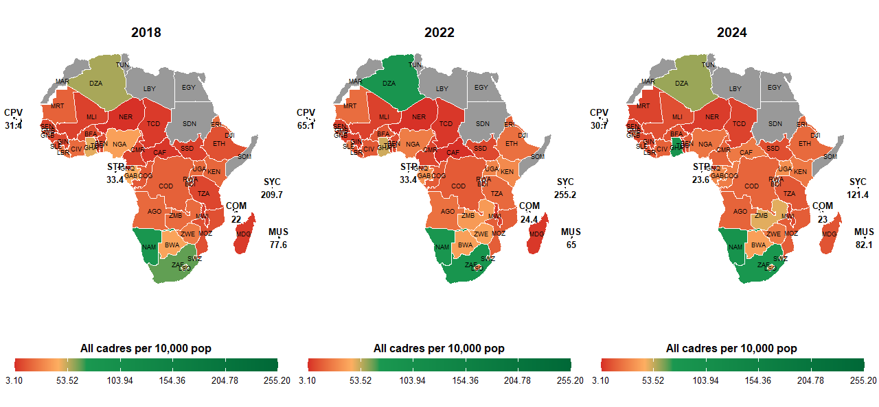
Health workforce…All cadres per 10,000 population.

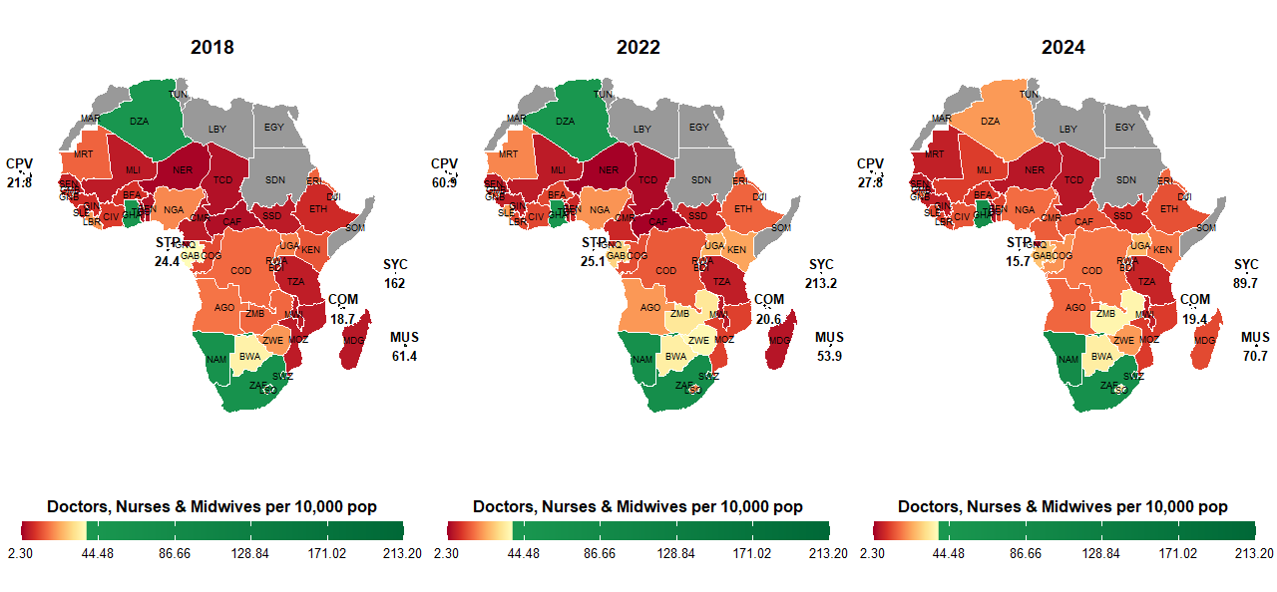

This Doctors, nurses and midwives, used a threshold of 35 since the doctors are 10, nurses at 23 and a margin for midwives per 10,000 population. You can also clarify this!

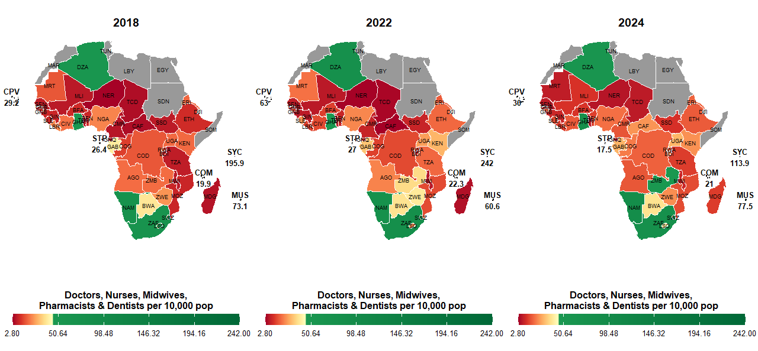
The threshold for this is 44.5 per 10,000 population

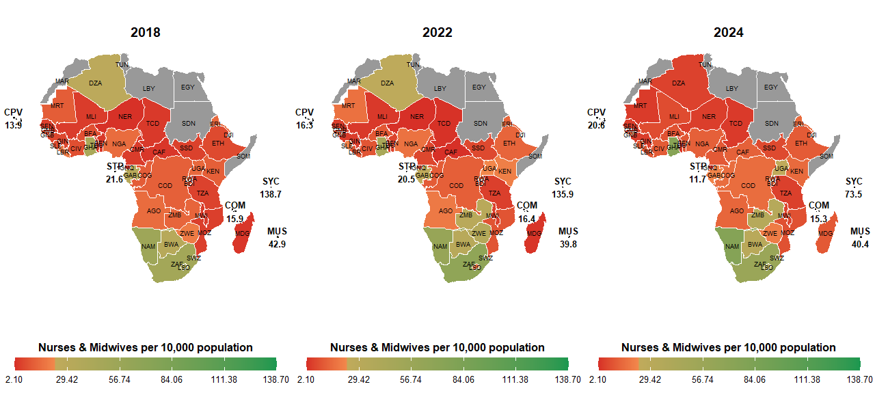
The threshold for the Nurses and midwives was taken as 23 per 10,000 population.
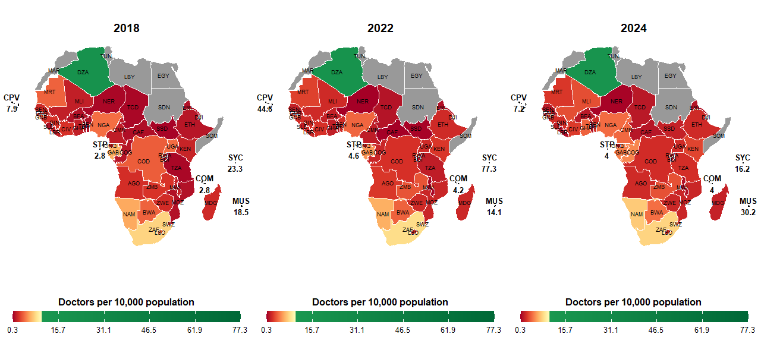
Figure 1: Health worker density per 10,000 population across WHO African Region countries, with SRHR service coverage indicated by colour intensity. Countries in red have both low workforce density and poor SRHR outcomes.

The threshold for doctors is 10 per 10,000 population.

3.0 METHODOLOGICAL FRAMEWORK

3.1 Overview of Integrated Modelling Approach
Our methodological framework represents a significant advancement in health workforce planning by integrating 14 distinct modelling approaches into a unified analytical system. This integration allows us to capture the complex, multi-dimensional nature of SRHR workforce planning while maintaining methodological rigor appropriate for different planning questions and data availability contexts.
The framework operates on three interconnected levels:
- Macro-level system dynamics for understanding broad trends and feedback loops
- Meso-level optimization for resource allocation decisions
- Micro-level simulation for individual career paths and service interactions

3.2 The 14 Integrated Modelling Approaches

3.2.1 Stock-and-Flow Models for Supply Projection
Stock-and-flow models form the foundation of our supply projection system, tracking health workers through various states over time. The extended formulation for multiple cadres is:
$$W(t+1)=A⋅W(t)+G(t)-L(t)+M(t)$$
Where:
$W(t)$: Vector of workforce stocks by cadre at time $t$
$A$: Transition matrix capturing career progression probabilities
$G(t)$: Graduation vector from training institutions
$L(t)$: Loss vector (attrition, retirement, death)
$M(t)$: Net migration vector (domestic and international)
For SRHR-specific applications, we incorporate:
- Gender-specific attrition rates reflecting different retention challenges
- Maternity leave and return-to-work probabilities
- Specialized SRHR training pipeline tracking
- Task-shifting transition probabilities
The dynamic attrition adjustment accounts for workload effects:
$$α_{k}(t)=α_{k,\text{base}}×\left(1+β×{\text{workload}}_{k}(t)+ε×\frac{Δ_{k}(t-1)}{D_{k}(t-1)}\right)$$
Where ${\text{workload}}_{k}(t)$ represents the ratio of actual to optimal workload for cadre $k$, and $Δ_{k}(t-1)/D_{k}(t-1)$ represents the previous period's gap relative to demand.

3.2.2 Needs-Based Demand Estimation Models
Our needs-based approach estimates workforce requirements based on population health needs rather than historical utilization or simple population ratios. The core equation for SRHR services is:
$$D_{k}(t)=\sum_{s∈S_{k}}{\frac{P(t)×p_{s}(t)×λ_{s,k}×C_{s}(t)}{μ_{s,k}(t)}}×\left(1 + δ\frac{{\text{DALY}}_{s}(t)}{{\text{DALY}}_{\text{global},s}}\right)$$
Where:
- $P(t)$: Population size
- $p_{s}(t)$: Prevalence of condition requiring service $s$
- $λ_{s,k}$: Service frequency per case for cadre $k$
- $C_{s}(t)$: Coverage target for service $s$ (0-1)
- $μ_{s,k}(t)$: Productivity (services per worker per year)
- $δ$: DALY adjustment coefficient reflecting disease burden severity
Productivity adjusts dynamically based on technology adoption and burnout:
$$μ_{s,k}(t)=μ_{s,k}^{\text{base}}×\left(1+γ×\text{tech.change}(t)-η×{\text{burnout}}_{k}(t)\right)$$
For SRHR applications, we incorporate specialized parameters:
- Service times for counseling-intensive SRHR services
- Privacy requirements affecting patient flow
- Gender considerations in service delivery
- Emergency response capacity requirements

3.2.3 Workforce Gap Analysis Models
The gap analysis model compares projected supply against estimated demand:
$$Δ_{k,r}(t)=D_{k,r}(t)-W_{k,r}(t)$$
Where $Δ_{k,r}(t)$ represents the gap (shortage if positive, surplus if negative) for cadre $k$ in region $r$ at time $t$.
We calculate several gap metrics:
- Absolute gap: $Δ_{k,r}(t)$
- Relative gap: $Δ_{k,r}(t)/D_{k,r}(t)$
- Coverage ratio: $W_{k,r}(t)/D_{k,r}(t)$
- Critical shortage flag: $I(Δ_{k,r}(t)/D_{k,r}(t)>θ_{k})$
Where $θ_{k}$ is a cadre-specific threshold (e.g., 0.1 for physicians, 0.15 for midwives).

3.2.4 Optimization Models for Resource Allocation
Optimization models identify the most efficient allocation of health workers given constraints. The objective function minimizes total cost and unmet demand:
$$min⁡\sum_{k=1}^{K}{\sum_{r=1}^{R}{\left[c_{k}W_{k,r}(t)+ϕ_{k}Δ_{k,r}(t)^{2}\right]}}$$
Subject to:
- Budget constraint: $\sum_{k,r}{c_{k}}W_{k,r}(t)≤B_{r}(t)$
- Skill mix constraints: $W_{j,r}(t)/W_{i,r}(t)≥ρ_{ij}$
- Minimum coverage: $W_{k,r}(t)≥W_{k,r}^{min}(t)$
- Training capacity: $G_{k}(t)≤Γ_{k}(t)$
- Equity constraints: Gini coefficient of distribution $≤$ target
For SRHR applications, we include additional constraints:
- Minimum female provider availability for gender-sensitive services
- Emergency obstetric care coverage requirements
- Adolescent-friendly service availability targets
- Privacy and confidentiality facility requirements

3.2.5 System Dynamics Models
System dynamics models capture feedback loops and time delays in the health workforce system. The basic structure uses differential equations:
$$\frac{dW}{dt}=I(W,D,t)-O(W,D,t)$$
Where inflows $I$ and outflows $O$ are functions of current stocks, demand, and time.
Key feedback loops modelled:
- Workload-burnout-attrition loop: High workload → burnout → increased attrition → higher workload on remaining staff
- Training pipeline delay: Training capacity decisions today affect workforce supply 3-7 years later
- Experience-productivity loop: Experienced workers are more productive but also more likely to leave for better opportunities
- Service quality-demand loop: Better quality services increase demand, requiring more workforce

3.2.6 Agent-Based Models (ABM)
ABMs simulate individual health workers and their interactions. Each agent $i$ has state variables:
- Cadre and specialization
- Experience level
- Location
- Burnout level
- Career intentions
- Personal characteristics (age, gender, family status)
Transition rules determine agent behavior:
- Career decisions based on utility functions
- Migration probabilities based on push-pull factors
- Productivity based on experience and working conditions
- Attrition probabilities based on satisfaction and alternatives
The model captures emergent phenomena:
- Clustering of health workers in urban areas
- Chain migration patterns
- Critical mass effects in training institutions
- Social network influences on career decisions

3.2.7 Microsimulation Models
Microsimulation tracks individual career paths through discrete event simulation:
$$T_{\text{next}}=min⁡\{t_{\text{event}}^{1},t_{\text{event}}^{2},…,t_{\text{event}}^{n}\}$$
Events include:
- Graduation from training
- Job placement
- Promotion
- Training participation
- Maternity/paternity leave
- Attrition
The model generates detailed distributions of:
- Career length by cadre and gender
- Training investment returns
- Retirement patterns
- Geographic mobility trajectories

3.2.8 Cohort-Based Simulation
Cohort models track groups of health workers who entered the system at the same time:
$$n(t+1)=A⋅n(t)$$
Where $n(t)$ is the cohort size vector and $A$ is the transition matrix with elements $a_{ij}$ representing the probability of moving from state $i$ to state $j$.
This approach is particularly useful for:
- Evaluating training pipeline investments
- Projecting retirement waves
- Analyzing generational differences in retention
- Planning succession for specialized positions

3.2.9 Skill-Mix Optimization Models
Skill-mix models determine the optimal combination of cadres for SRHR service delivery:
$$min⁡\sum_{k=1}^{K}{c_{k}}x_{k}$$
Subject to service delivery constraints:
$$\sum_{k=1}^{K}{a_{ik}}x_{k}≥b_{i}∀i∈\text{Services}$$
And quality constraints:
$$\sum_{k=1}^{K}{q_{ik}}x_{k}≥Q_{i}∀i∈\text{Quality dimensions}$$
Where:
- $a_{ik}$: Capacity of cadre $k$ to deliver service $i$
- $q_{ik}$: Quality contribution of cadre $k$ to dimension $i$
- $b_{i}$: Minimum required service $i$
- $Q_{i}$: Minimum quality threshold for dimension $i$

3.2.10 Stochastic Models for Uncertainty Analysis
Stochastic models incorporate uncertainty through probability distributions for key parameters:
$$dW(t)=μ(W,t)dt+σ(W,t)dB(t)$$
Where $B(t)$ is Brownian motion representing random fluctuations.
Monte Carlo simulation generates probability distributions for outcomes:
- Probability of achieving workforce targets
- Risk of critical shortages
- Confidence intervals for gap estimates
- Value at risk for different investment strategies

3.2.11 Econometric Models for Causal Inference
Econometric models analyze relationships between workforce variables and outcomes:
$$Y_{it}=α_{i}+βX_{it}+γZ_{it}+ϵ_{it}$$
Where:
- $Y_{it}$: Outcome for country $i$ at time $t$ (e.g., maternal mortality ratio)
- $X_{it}$: Workforce variables (density, skill-mix, distribution)
- $Z_{it}$: Control variables (GDP, education, infrastructure)
- $α_{i}$: Country fixed effects
- $ϵ_{it}$: Error term
We employ various econometric techniques:
- Fixed effects and random effects models
- Instrumental variables for endogeneity
- Difference-in-differences for policy evaluation
- Regression discontinuity for threshold effects

3.2.12 Time-Series Models for Trend Analysis
Time-series models forecast future trends based on historical patterns:
$$ϕ(B)(1-B)^{d}Y_{t}=θ(B)ϵ_{t}$$
Where:
- $ϕ(B)$: Autoregressive polynomial
- $θ(B)$: Moving average polynomial
- $B$: Backshift operator
- $d$: Differencing order
- $ϵ_{t}$: White noise error
Applications include:
- Projecting workforce growth trajectories
- Identifying seasonal patterns in service demand
- Detecting structural breaks from policy interventions
- Forecasting retirement waves

3.2.13 Workload Indicators of Staffing Need (WISN) Methodology for Workload-Based Staffing
The Workload Indicators of Staffing Need (WISN) method calculates staffing requirements based on workload:
$$\text{WISN}=\frac{\text{Total Workload}}{\text{Available Working Time}}×(1+\text{Allowance Factor})$$
Where:
- Total Workload = $∑(\text{Activity Standard}×\text{Annual Volume})$
- Available Working Time = Annual working days × hours per day × utilization rate
- Allowance Factor = Combined allowances for additional activities
For SRHR services, we develop specialized activity standards:
- Antenatal care consultations (including counseling time)
- Delivery attendance (normal and complicated)
- Family planning counseling and service provision
- Post-abortion care
- STI diagnosis and treatment
- Adolescent SRHR counseling

3.2.14 Manpower Planning Models
Manpower planning models align workforce supply with long-term organizational needs:
$$M(t)=P⋅M(t-1)+R(t)-L(t)$$
Where:
- $M(t)$: Manpower vector by grade/position
- $P$: Promotion matrix
- $R(t)$: Recruitment vector
- $L(t)$: Loss vector
These models support:
- Career structure design
- Succession planning
- Leadership pipeline development
- Specialized training planning

3.3 Integration Framework
The 14 modelling approaches are integrated through a hierarchical structure:
- Foundation layer: Stock-and-flow, needs-based, and gap analysis models provide baseline projections
- Analysis layer: Econometric, time-series, and stochastic models analyze relationships and uncertainties
- Optimization layer: Optimization, skill-mix, and WISN models identify efficient solutions
- Simulation layer: System dynamics, agent-based, and microsimulation models test interventions
- Planning layer: Manpower planning and cohort models support long-term strategy
Figure: Hierarchical structure of integrated modelling framework
Figure 2. Hierarchical integration of 14 modelling approaches showing information flows between layers.

3.4 Structural Equation Modelling (SEM) Framework
The SEM framework analyzes the pathways through which health workforce investments affect SRHR outcomes:
Structural Model:
$$η_{2}=γ_{21}η_{1}+ζ_{2} \\ η_{3}=γ_{31}η_{1}+β_{32}η_{2}+ζ_{3} \\ η_{4}=β_{43}η_{3}+ζ_{4} \\ η_{5}=β_{54}η_{4}+γ_{51}η_{1}+ζ_{5}$$
Where:
- $η_{1}$: Investment (latent)
- $η_{2}$: Efficiency (latent)
- $η_{3}$: Output (latent - service coverage)
- $η_{4}$: Outcome (latent - health outcomes)
- $η_{5}$: Impact (latent - economic and social)
Measurement Models connect latent constructs to observed variables:
- Investment: Health worker density, training expenditure, salaries
- Efficiency: Skill-mix ratios, workload balance, retention rates
- Output: Service coverage indices for different SRHR services
- Outcome: DALYs, maternal mortality, contraceptive prevalence
- Impact: GDP growth, labor participation, poverty reduction
Total Effects Decomposition:
$${\text{Total Effect}}_{Investment→Impact}=γ_{51}+γ_{21}β_{32}β_{43}β_{54}+γ_{31}β_{43}β_{54}$$
This allows calculation of:
- Direct effects of investment on impact
- Indirect effects mediated through efficiency and output
- Return on investment (ROI) estimates

3.5 Modern Portfolio Theory (MPT) Application
We apply MPT to health workforce planning by treating different cadres as assets in a portfolio:
Portfolio Setup:
- Assets: Health workforce cadres (doctors, nurses, midwives, etc.)
- Returns: Health outcome improvements (DALYs averted)
- Risks: Attrition, skills mismatch, wage inflation
- Correlation: Task-shifting possibilities between cadres
Mathematical Formulation:
Expected return of portfolio:
$$E[R_{p}]=\sum_{i=1}^{n}{w_{i}}E[R_{i}]$$
Portfolio risk (variance):
$$σ_{p}^{2}=\sum_{i=1}^{n}{\sum_{j=1}^{n}{w_{i}}}w_{j}σ_{i}σ_{j}ρ_{ij}$$
Where:
- $w_{i}$: Portfolio weight of cadre $i$
- $E[R_{i}]$: Expected return (DALYs averted) of cadre $i$
- $σ_{i}$: Risk (attrition variance) of cadre $i$
- $ρ_{ij}$: Correlation between returns of cadres $i$ and $j$
The efficient frontier identifies optimal cadre mixes that maximize returns for given risk levels.

3.6 Data Requirements and Sources
Our modelling framework utilizes data from multiple sources:
Primary Data Sources:
- WHO Global Health Observatory
- World Bank World Development Indicators
- ILO Labor Statistics
- UNESCO Education Statistics
- National Health Workforce Accounts
- Demographic and Health Surveys (DHS)
- Service Availability and Readiness Assessments (SARA)
- National health strategic plans and budgets
Data Categories Collected:
- Demographic data: Population size, age structure, fertility rates
- Epidemiological data: Disease prevalence, DALYs, mortality rates
- Health workforce data: Stock, distribution, skill-mix, attrition
- Training data: Enrollment, graduation, specialization
- Financial data: Health expenditure, salaries, training costs
- Service data: Coverage, utilization, quality indicators
- Economic data: GDP, employment, poverty rates
- Geographic data: Facility locations, population distribution
Data Processing Pipeline:
- Data extraction and harmonization
- Missing data imputation using multiple imputation techniques
- Outlier detection and treatment
- Variable transformation and creation
- Panel data structuring for longitudinal analysis
- Geographic information system (GIS) integration for spatial analysis

4.0 RESULTS AND FINDINGS

Modelled Operating Environment where HRH Operate in the WHO African Region and the Linkage from Investments to Outputs, Outcomes and Impacts

Health systems in the African Region operate within complex, resource-constrained environments where the relationship between investments, financial and human, and population health outcomes is neither linear nor immediate. Understanding this operating environment requires a multi-method, multi-scale approach that captures the dynamics of health workforce supply, financing allocations, skill-mix efficiency, and their downstream effects on Universal Health Coverage (UHC), life expectancy, maternal and infant mortality, and productivity. This chapter synthesises seven modelling studies, each addressing a distinct dimension of the HRH operating environment. Collectively, they trace the causal pathway from investments (government, donor, private financing) to outputs (workforce density, coverage ratios), outcomes (UHC service coverage, disease burden), and impacts (life expectancy, mortality, economic productivity). Each study is presented as a self-contained subsection, with the methods and results supported by empirical data. A synthesis is provided at the of this chapter.

Study 1: Health Workforce and Financing Dynamics – Fixed Effects Panel Analysis of Life Expectancy and Universal Health Coverage
Introduction: Understanding how health workforce density and government health financing shape population health outcomes is critical for guiding policy toward Universal Health Coverage (UHC). Using longitudinal panel data from 47 countries over up to 18 years, this study applies fixed-effects and dynamic fixed-effects models to disentangle the short- and long-run impacts of doctors, nurses/midwives, and health financing on life expectancy (LE) and UHC service coverage. By controlling for structural country differences and economic development, the analysis provides robust insights into how human resources for health (HRH) contribute to health system performance.
Main Objective: To evaluate the relationship between health workforce density and government health financing with key health outcomes, life expectancy and UHC service coverage, using fixed-effects panel regression models.
Specific Objectives
- To assess the effect of doctor and nurse/midwife densities on life expectancy.
- To evaluate the impact of government health expenditure per capita and GDP per capita on life expectancy.
- To analyze the role of health workforce density in shaping UHC service coverage.
- To distinguish short-run and long-run effects of HRH and financing using dynamic fixed-effects models.
- To estimate elasticities that quantify the percentage change in outcomes associated with sustained increases in HRH density.
Methods
Fixed Effects Model – Controlled for country-specific structural differences (e.g., geography, institutions, long-standing health system features).
$$Y_{it}=α_{i}+β_{1}{\text{Doctors}}_{it}+β_{2}{\text{NursesMidwives}}_{it}+β_{3}{\text{GGHED}}_{it}+β_{4}{\text{GDP}}_{it}+e_{it}$$
where $Y_{it}$ is either Life Expectancy (LE) or UHC_SCI (two models are fitted).
Dynamic Fixed Effects Model – Included a lagged dependent variable to capture persistence over time and distinguish short-run from long-run effects.
$$Y_{it}=α_{i}+ρY_{i,t-1}+β_{1}{\text{Doctors}}_{it}+β_{2}{\text{NursesMidwives}}_{it}+β_{3}{\text{GGHED}}_{it}+β_{4}{\text{GDP}}_{it}+e_{it}$$
Elasticity Estimation – Derived from dynamic models to measure the percentage change in outcomes associated with a sustained 1% increase in HRH density.
Results
Life Expectancy (LE) – In the static fixed-effects model, doctor density showed a negative coefficient (−0.3048, p < 0.001). However, this finding should be interpreted cautiously: it may reflect complex factors such as the concentration of doctors in sicker populations or unmeasured disease burden. Additionally, the optimization studies will identify an appropriate optimal doctors density which is currently outside the current panel data on the ground. In contrast, nurse and midwife density was positively associated with life expectancy (+0.1119, p < 0.001). Government health expenditure per capita (+0.0302, p < 0.001) and GDP per capita (+0.000925, p < 0.001) were also positively correlated with LE.
The dynamic model, which includes lagged life expectancy (coefficient = 0.9111, p < 0.001), provides a more conservative estimate. In this specification, the coefficient for doctors becomes much smaller (−0.0733, p < 0.001), and nurses/midwives no longer show a statistically significant independent short-run effect. The model’s within R² is 0.97, reflecting the strong inertia of population longevity.
UHC Service Coverage (UHC_SCI) – In the static fixed-effects model, nurse and midwife density was strongly associated with higher UHC service coverage (+0.336, p < 0.001). Doctor density showed no significant association. GDP per capita was also positively associated (+0.00357, p < 0.001). Government health expenditure per capita was not statistically significant.
The dynamic model (lagged UHC coefficient = 0.904, p < 0.001) confirms strong persistence. In this specification, nurses and midwives retain a positive and significant short-run effect (+0.045, p = 0.014), while doctors remain non-significant. The adjusted R² is 0.898.
Elasticities – Long-run elasticities derived from the dynamic models:
Interpretation: A 1% sustained increase in nurse and midwife density is associated with a 0.151% long-run improvement in UHC service coverage.
Punchlines
- Nurses and midwives drive UHC gains – a 1% sustained increase in their density yields a 0.151% long-run rise in UHC service coverage.
- Life expectancy is highly persistent – past values explain 97% of the variation; workforce effects are modest once inertia is accounted for.
- Doctor density coefficients are not causal – negative signs likely reflect confounding by disease burden, not harmful effects.
Conclusion and Recommendations
The analysis shows that nurses and midwives are the most consistent health workforce drivers of UHC service coverage, with positive short-run and long-run effects. For life expectancy, past levels and broader economic factors dominate. Negative coefficients for doctors should not be misinterpreted; they highlight the need for careful model specification.
Recommendations
- Prioritise nursing and midwifery expansion as a core strategy for advancing UHC.
- Sustain government health financing to reinforce long-term improvements in both LE and UHC.
- Incorporate elasticity estimates into workforce planning.
- Adopt dynamic planning approaches that recognise the strong persistence and lagged effects in population health outcomes.

All cadres analytics (FIXED EFFECTS MODELS (PANEL REGRESSION))
A longitudinal panel analysis using annual country-level data for 47 countries observed over an unbalanced period spanning up to 18 years. The analysis combined demographic, macroeconomic, health financing, health workforce, and health outcome indicators to examine the relationship between human resources for health (HRH) and key health system outcomes. The data was sourced from credible international sources including WHO and world bank.
Two primary outcomes were examined the life expectancy at birth (LE) measured in years and used as a summary indicator of population health and Universal Health Coverage Service Coverage Index (UHC_SCI). The main explanatory variable of interest was measures of health workforce availability, expressed as densities per population:
Workforce density was constructed as the number of physicians, pharmacists, dentists, and nursing/midwifery personnel per 10,000 population. To account for broader demographic, health system and economic context, the models also included . The ratio of Government health expenditure per capita (GGHED per capita) to Gross domestic product per capita (GDP per capita) and population density.
The main objective was to estimate the association between health workforce density and UHC service coverage and life expectancy; assess nonlinear and threshold effects in the workforce–outcome relationship; and identify workforce density levels associated with diminishing marginal returns.
First, we estimate the longitudinal association between health workforce density and health system performance, measured by life expectancy at birth (LE) and the Universal Health Coverage Service Coverage Index (UHC_SCI), using country-level panel data.
We then test for the presence of a structural breakpoint (kink) in the workforce–outcome relationship, allowing for differential marginal effects below and above an empirically determined workforce density threshold.
Finally, we identify the workforce density level at which marginal returns to workforce expansion decline, indicating a transition from a workforce-constrained regime to a moderate-return regime.
Statistical Approach
Panel regression models were estimated using both fixed-effects and random-effects specifications. Hausman tests were used to guide model selection.We then added a kink (piecewise linear) model that allows the marginal effect of an explanatory variable to change at an unknown threshold. The baseline Panel model is given by:
$$Y_{it}=∝_{i}+τ_{t}+βW_{it}+X_{it}+ϵ_{it}$$
Where
$Y_{it}$= outcome variable (e.g., LE or UHC_SCI)
$W_{it}$ = workforce density
$X_{it}$= vector of control variables
$∝_{i}$= country-specific fixed effect
​ $τ_{i}$= time (year) fixed effect
$ϵ_{it}$- Error term
To allow for a structural change in marginal effects at an unknown threshold $k$, we define
$${(W_{it}-k)}_{+}=max⁡(0,W_{it }-k)$$
The kink model will be
$$Y_{it}=∝_{i}+τ_{t}+β_{1}W_{it}+β{(W}_{it}-k)+X_{it}+ϵ_{it}$$
The threshold is estimated as
$$\hat{k}=\sum_{i,t }{}{{\hat{ϵ}}_{it}^{2}}_{}$$
Results
Universal Health Coverage
We compared the fitted fixed effects and random effects model. From the Hausman test ($χ^{2}=11.5, df=25, p-value<0.001)$,we rejected the null hypothesis and conclude that the random effects model was inconsistent because the individual-specific errors are correlated with the regressors. We therefore report the fixed effects model.
In fixed-effects panel models adjusting for year effects, population density and government health expenditure ,workforce density was positively associated with UHC service coverage. A one-unit increase in workforce density (per 10,000 population) was associated with a 0.11-point increase in UHC-SCI (β = 0.110, p = 0.004). The coefficients for factor(Year) show a clear upward trend. Starting around 2006, the time effects become highly significant and increase in magnitude (from 10.8 in 2006 to 22.9 in 2023). This indicates a strong global or systemic improvement in UHC scores over time that isn't explained by your three main independent variables.
From the piece wise regression, the estimated kink term capturing a change in marginal returns above the candidate threshold was not statistically significant (β = 0.043, p = 0.72), indicating no evidence of a discrete breakpoint in the workforce - UHC relationship.
A grid-search procedure was used to identify the workforce density threshold minimizing the residual sum of squares in fixed-effects models. The optimal breakpoint was identified at approximately 9 health workers per 10,000 population for UHC (figure 1). This threshold represents the transition from ‘extreme health workforce crisis’ to ‘basic functional capacity’. It is the point where basic primary care geared towards UHC begins to stabilize. However, the slope-change parameter was not statistically significant, suggesting that while marginal returns may diminish beyond this level, there is no evidence of a discrete structural break.
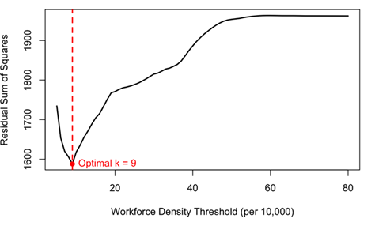
Figure 2: Workforce density threshold for UHC
Life expectancy outcome
There was no statistically significant difference between the fixed effects and random effects coefficients (Hausman test ($χ^{2}=0.0669, df=23, p-value=0.9999$ )).
In random-effects panel models adjusting for population density, government health expenditure, and year effects, workforce density was not significantly associated with life expectancy (β = 0.016, p = 0.41). The estimated slope change above the optimal breakpoint (38 workers per 10,000 population) was negative but statistically insignificant (β = –0.079, p = 0.16), providing no evidence of a structural threshold in the workforce–longevity relationship. The life expectancy at birth (LE) threshold of 38.0 is closer to the broader WHO global benchmarks and represents the population health impact.
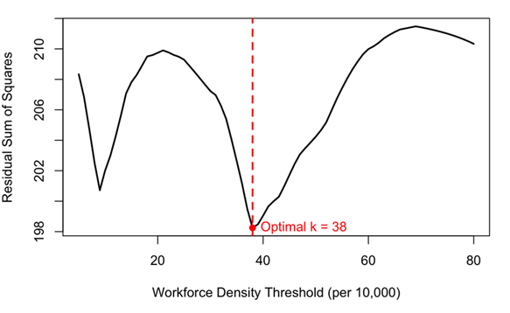
Figure 3: Workforce density threshold for Life Expectancy

Comparison
Health workforce density is a critical driver for the UHC Service Coverage Index( UHC_SCI) but does not significantly impact life expectancy. Hiring more health workforce directly improves service delivery (vaccinations, prenatal care, hospital access), which raises the UHC score.On the other hand, life expectancy is influenced by broader factors not necessarily the health work force.
While a density of 9 health workers per 10,000 serves as the critical breakpoint for expanding service coverage (UHC), a significantly higher density of 38 per 10,000 is required to achieve structural improvements in life expectancy. This suggests that service coverage is a necessary but insufficient precursor to longevity, requiring nearly a four times increase in workforce density to translate into extended life expectancy.

Study 2: Investing in Health Systems - Insights into How Current Health Financing Allocations Shape UHC Service Coverage and Key Health Outcomes
Introduction: Health financing is central to achieving 100% Universal Health Service Coverage (UHC). WHO standards emphasize raising sufficient funds, pooling risks fairly, and purchasing services strategically to ensure people have access to quality care without financial hardship. Most countries in Africa face challenges such as high out-of-pocket (OOP) spending, fragmented risk pools, underfunding of public health, and overreliance on donor funding. This study investigates how the composition of Current Health Expenditure (CHE) - comprising government (GGHED), external donor (EXT), and private (PVTD) funding - affects key health outcomes and Universal Health Coverage (UHC) in Africa. Using data from 47 WHO African countries (2000 - 2024), the study identifies optimal financing ratios that maximise life expectancy (LE) and UHC service coverage while minimising maternal (MMR) and infant mortality (IMR).

“Health financing is not just about spending more, but spending better and pooling risks fairly”.

Main Objective: To determine the optimal allocation of government, donor, and private health expenditure that maximises health outcomes and UHC service coverage across African countries.
Specific Objectives
- Examine the nonlinear relationship between total CHE and key health outcomes (LE, MMR, IMR, UHC_SCI).
- Quantify the individual effects of GGHED, EXT, and PVTD on each health outcome using a generalised additive model (GAM).
- Derive optimal expenditure proportions that minimise mortality and maximise coverage and life expectancy.
- Assess the impact of increasing government health expenditure beyond 67% of CHE on national health performance indicators.
Methods
The analysis employed a Generalised Additive Model (GAM) to capture nonlinear relationships:
$$g(E[KHO])=β_{0}+f_{1}(\text{EXT})+f_{2}(\text{GGHED})+f_{3}(\text{PVTD})+ε$$
where $g(⋅)$ is the link function, $f_{j}(⋅)$ are smooth functions, and KHO represents key health outcomes (LE, MMR, IMR, UHC_SCI). The fitted GAM results were then used in a nonlinear optimisation model:
$$\underset{j}{min⁡}f_{j}(i)\text{subject to}ω_{ij}≥0, \sum_{i}{ω_{ij}}=1, {\text{CHE}}_{j}=ω_{1}\text{EXT}+ω_{2}\text{GGHED}+ω_{3}\text{PVTD}$$
Results
Optimal financing mixes for each outcome:
- Life expectancy (LE): GGHED 50%, PVTD 36%, EXT 14%
- Maternal mortality (MMR): GGHED 92%, EXT 8%, PVTD 0%
- Infant mortality (IMR): GGHED 44%, PVTD 39%, EXT 17%
- UHC service coverage (UHC_SCI): GGHED 82%, EXT 18%, PVTD 0%
Average optimal composition across all outcomes: GGHED 67%, PVTD 19%, EXT 14%.
Performance of countries investing more than 67% of CHE through government funding (compared to regional average):
- UHC index higher by 26%
- Life expectancy higher by 12.5 years
- Maternal mortality reduced by 414 deaths per 100,000 live births
- Infant mortality reduced by 34 deaths per 1,000 live births
Punchlines
- “67% government share is the tipping point” – countries above this threshold achieve +12.5 years of life expectancy and 414 fewer maternal deaths per 100,000 live births compared to the regional avarege.
- Government-led investment drives the greatest health gains – the optimal mix for MMR is 92% government, 8% external, 0% private.
- Strategic allocation, not donor dependency, builds sustainable health systems.
Conclusion and Recommendations
Government health expenditure is the most influential determinant of improved health outcomes and service coverage. Increasing public investment to at least 67% of total CHE yields substantial gains.
Recommendations:
- Governments should target at least 67% of total CHE.
- Donor funding should align with national priorities, supporting system resilience.
- Private sector participation should focus on efficiency and innovation, not primary financing.
- Shift emphasis from volume to value.

Study 3: Investing in Health Systems – Insights into How Health Financing Shapes Workforce Density and UHC Outcomes
Introduction: Workforce density, particularly the availability of doctors, nurses, midwives, dentists, and pharmacists, is a critical determinant of service coverage and equity. This study explores how government health financing influences workforce density and, consequently, UHC outcomes across African countries.
Main Objective: To examine the relationship between government health financing and health workforce density, and how this interaction shapes progress toward achieving UHC service coverage thresholds.
Specific Objectives
- Determine the minimum average proportion of health workers required to achieve 70% UHC service coverage.
- Assess the effect of government health financing on workforce density using panel data models.
- Evaluate the sensitivity (elasticity) of workforce density to changes in government health expenditure.
- Identify threshold levels of government health expenditure where the relationship changes significantly.
- Analyse lagged effects of government health financing on workforce density over time.
Methods
In this section, we determine whether government financing on health (GGHED) has any effect on health workforce (HWF) densities and whether an increase in government expenditure has infinite or diminishing returns. A generalized additive model (GAM) was first fitted to the data to help us capture current or any delayed effects that government health expenditure has on health workforce density, where the current to the fifth GGHED lags were included in the model. The fitted GAM model was given by:
$${HWF}_{it}=α{+f(GGHED}_{it}){+f(GGHED}_{i(t-1)}){+f(GGHED}_{i(t-2)}){+f(GGHED}_{i(t-3)})$$
${+f(GGHED}_{i(t-4)}){+f(GGHED}_{i(t-5)})+e_{it}$
Finally, using the GAM results, we computed the health workforce density elasticity with respect to the government expenditure (GGHED) at different levels. This was done to allow us to measure the percentage change in health workforce density for a percentage increase in GGHED. The elasticity function was given by:
$$Elasticity=\frac{∂HWF}{∂GGHED}*\frac{GGHED}{HWF}$$

Results
The fitted lagged GAM model was found to have an explained deviance of 85.3% and adjusted $R^{2}$ of 83.6% with an intercept of α=17.57***, and the smoothed parameter estimates were as summarized in Table 1:
Table 1: Lagged GAM Model Results on the effect of GGHED per capita on HWF
Variable | edf | Ref.df | F-value | pvalue
f(GGHED_Lag0) | 8.174 | 8.745 | 3.716 | 0.0002
f(GGHED_Lag1) | 1.000 | 1.000 | 0.156 | 0.6930
f(GGHED_Lag2) | 1.433 | 1.769 | 0.735 | 0.5703
f(GGHED_Lag3) | 1.000 | 1.000 | 2.746 | 0.0989
f(GGHED_Lag4) | 6.419 | 7.558 | 1.669 | 0.1299
f(GGHED_Lag5) | 8.203 | 8.762 | 4.383 | 0.0000

Table 1 results show that current and 5-year lagged government spending levels on health (GGHED) have a strong non-linear (both edfs>>1), significant effect on health workforce density. However, the strongest non-linear effect is observed after 5 years, suggesting that health financing has a delayed effect, which translates into workforce growth through other constraints such as training, retention, and so on. Implying that government health expenditure per capita influences health workforce density both immediately (maybe through hiring, retention, or salary adjustments) and through delayed long-term effects (maybe through training and deployment of health workers).
The non-linear effect of the current and 5-year lagged GGHED levels on workforce densities implied that there might be different thresholds depicting a possibility of diminishing returns. This is why a lagged GAM threshold model was fitted to the data to determine whether indeed there are any thresholds in the data where the derivatives of the smoothed estimates change signs, showing the direction where expenditure changes highlight phases of growth and decline in health workforce densities. The current and 5-year lagged government health expenditure threshold effects on health workforce were extracted from the fitted lagged GAM threshold model, and the results were summarized in Tables 2 and 3 as visualized in Figures 3 and 4.
Table 2: GGHED Threshold on HWF
GGHED per capita, $ | Derivative
29 | 0.0211
87 | -0.0144
162 | 0.0106
337 | -0.0226
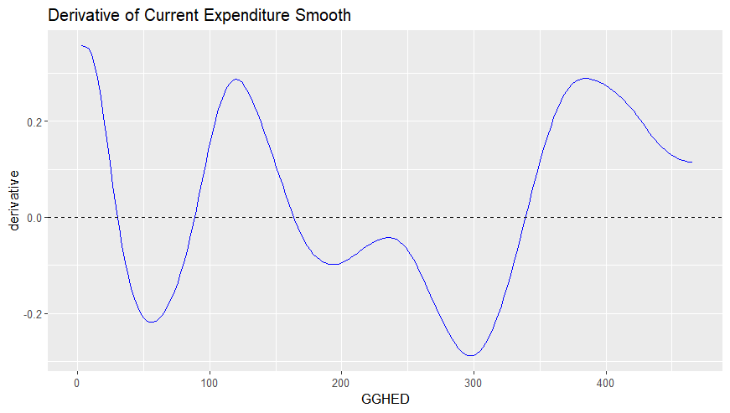
Figure 4: Current GGHED Threshold Effects on HWF
Table 2 show that for current levels of government financing on health, thresholds occur at 29, 87, 162, and 337 dollars per capita, showing alternating phases of growth and decline as spending increases (See Figure 4).
Table 3: Five-Year Lagged GGHED Threshold on HWF
GGHED per capita, $ | Derivative
81 | 0.0117
129 | -0.0005
174 | 0.0066
214 | -0.0167
300 | 0.0107
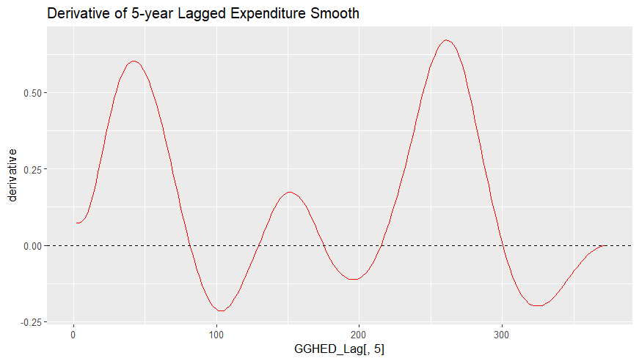
Figure 5: Five-Year Lagged GGHED Threshold

Effects GGHED on HWF

Similarly, Table 3 shows that for 5-year lagged levels of government financing on health, thresholds occur at 81, 129,174, 214 and 300 dollars per capita, showing alternating phases of growth and decline as spending increases (See Figure 5). Both the current and 5-year lag threshold models showed there are levels of government expenditure (GGHED) on health where the derivatives of the smooth function f(.) changes sign. Periods with positive derivatives imply that increased expenditure at those levels lead to increased workforce growth whereas periods with negative derivatives imply that at these levels, increased expenditure yields diminishing or negative returns on health workforce densities, implying that more health spending doesn’t guarantee more workforce as efficiency and allocation also matter.
Figure 6 shows the effect of government expenditure on health workforce density and the resulting elasticity levels for different levels of government health financing.

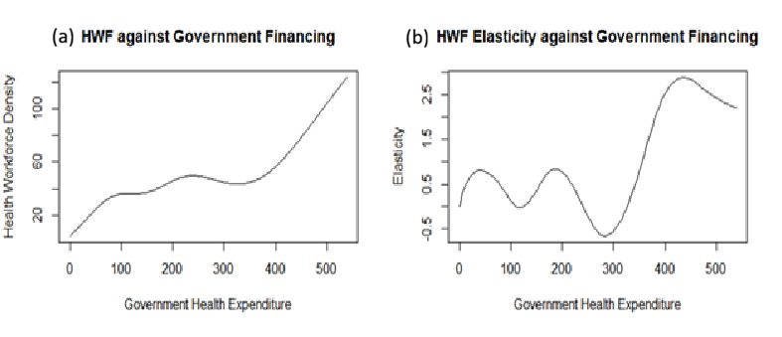
Figure 6: Effect of Government Financing on Health Workforce Density and Elasticity
Figure 6a) shows that health workforce density increases with an increase in government expenditure, although not linearly. Figure 6b) shows that health workforce elasticity levels increase and decrease at different levels of GGHED, with local optimum GGHED levels per capita recorded at $40.75, $186.83, and $438.41, responding to a local optimum total of 21.12, 43.46, and 72.88 doctors, nurses, midwives, pharmacists, and dentists collectively per 10,000 population, respectively.
From our results in the previous study, we found that to collectively achieve optimal health outcomes, such as increased life expectancy, improved health coverage, and reduced maternal and infant mortality ratios, we need an average of 78.16 doctors, nurses, midwives, pharmacists, and dentists collectively. This results in a GGHED of $449.23 per capita. Hence, governments that plough in an amount of $449.23 per capita towards their current health expenditure are set to see optimal health outcomes. However, for governments that are unable to reach these GGHED levels can work hard towards achieving the local optimum levels, either at $40.75 per capita, or $186.83 per capita, or $438.41 per capita.

Study 4: Investing in Health Systems – Insights into How Health Workforce Density Shapes UHC and Health Outcomes (Life Expectancy, MMR, IMR)
Introduction: This study investigates how different cadres of health workers - doctors, nurses/midwives, dentists, and pharmacists - contribute to UHC, life expectancy (LE), maternal mortality ratio (MMR), and infant mortality rate (IMR), while identifying thresholds beyond which additional investments yield diminishing returns.
Main Objective: To determine the optimal health workforce density allocations across cadres that maximise UHC and key health outcomes before diminishing returns set in.
Specific Objectives
- Establish the minimum distribution of cadres required to achieve at least 70% UHC.
- Analyse the effect of workforce density on LE, MMR, IMR, and UHC_SCI.
- Identify optimal density thresholds for each cadre before diminishing returns occur.
- Derive average workforce allocations that balance improvements across multiple outcomes.
Methods
Descriptive analysis – Historical data from WHO African countries to determine densities associated with 70% UHC.
Generalised Additive Model (GAM):
$$g(E[KHO])=β_{0}+f_{1}(\text{Workforce_Cadre})+e$$
Threshold analysis – Identified cadre-specific density levels beyond which additional investments yield diminishing returns.
Results
Minimum workforce distribution for 70% UHC:
Doctors: 11.09, Dentists: 2.19, Nurses/midwives: 28.53, Pharmacists: 2.81 per 10,000 population.
Optimal thresholds per 10,000 population (beyond which gains plateau): This happens when you have all the resources/money to invest. At what point will you stop investing for each of the different health outputs, outcomes, and impacts? See Table 4:
Table 4: Optimal thresholds for each of the densities per 10,000 population, when resources are unlimited
Health Variable | Doctors | Nurses & Midwives | Dentists | Pharmacists
Life Expectancy (LE) | 30.52 | 29.25 | 2.57 | 5.15
Maternal Mortality (MMR) | 11.96 | 60.91 | 2.17 | 10.08
Infant Mortality (IMR) | 31.61 | 46.35 | 2.85 | 7.96
UHC Service Coverage | 12.69 | 47.44 | 3.16 | 7.88
Averages | 21.7 | 45.99 | 2.69 | 7.77

Interpretive punchlines with data:
- For life expectancy to significantly increase, we need 31 doctors, 30 nurses/midwives, 3 dentists and 6 pharmacists per 10,000 population. Beyond these numbers, no further change in LE.
- For UHC service coverage to increase, we need 13 doctors, 48 nurses/midwives, 4 dentists and 8 pharmacists per 10,000 population.
- For maternal deaths to rapidly reduce, we need 12 doctors, 61 nurses/midwives, 3 dentists and 11 pharmacists.
- For infant deaths to be reduced, we need 32 doctors, 47 nurses/midwives, 3 dentists and 8 pharmacists.
- On average across all outcomes: 22 - 32 doctors, 46 - 61 nurses/midwives, 3 - 4 dentists, and 8 - 11 pharmacists per 10,000 population.
Punchlines (contextualised)
- “Longevity rises when specialists and primary care walk hand in hand” – 31 doctors + 30 nurses/midwives per 10,000.
- “Maternal survival depends most on nurses and midwives” – 61 nurses/midwives per 10,000 needed.
- “Infant survival is secured by a balanced mix” – 32 doctors, 47 nurses, 3 dentists, 8 pharmacists.
- “Universal coverage is not about sheer numbers, but the right distribution” – 13 doctors, 48 nurses, 4 dentists, 8 pharmacists.
Conclusion and Recommendations
Health workforce density strongly influences outcomes, but benefits plateau beyond specific thresholds.
Recommendations
- Target densities of 22 - 32 doctors, 46 - 61 nurses/midwives, 3 - 4 dentists, 8 - 11 pharmacists per 10,000 population depending on the country experience.
- Prioritise balanced workforce planning rather than uniform distribution.
- Integrate workforce thresholds into national health strategies.

Study 5: Optimizing the Health Workforce Skill-Mix Using Modern Portfolio Theory – Considering a 70% Budget Allocation Framework for Core Cadres and Community Health Workers
Introduction: This study applies Modern Portfolio Theory (MPT) to Human Resources for Health (HRH), treating the health workforce as a portfolio of assets. By framing cadres - nurses, midwives, dentists, pharmacists, doctors, and community health workers (CHVs) - as assets with returns (DALYs gained) and risks (attrition, shortages, shocks), MPT provides a structured approach to optimise workforce composition. Efficiency gains can be achieved by reallocating existing budgets across cadres rather than expanding workforce size.
Main Objective: To optimise HRH skill-mix using MPT, ensuring maximum health outcomes per unit of expenditure under uncertainty and fiscal constraints, with a specific focus on allocating 70% of the HRH budget to core cadres and CHVs.
Specific Objectives
- Define six cadres as portfolio assets with measurable returns and risks.
- Estimate optimal allocations subject to a collective budget ceiling of 70% of total HRH expenditure.
- Identify efficient frontiers of workforce composition.
- Demonstrate the role of diversification in mitigating systemic shocks.
- Highlight efficiency gains achievable through reallocation of existing budgets.
Methods
Asset definition: Nurses, midwives, dentists, pharmacists, doctors, CHVs. Returns = DALYs per unit budget. Risk = variance in health outcomes.
Optimisation equations – Maximise expected portfolio return:
$$E(R_{p})=\sum_{i=1}^{6}{w_{i}}R_{i}$$
Subject to portfolio variance constraint:
$$Var⁡(R_{p})=\sum_{i=1}^{6}{\sum_{j=1}^{6}{w_{i}}}w_{j}σ_{ij}$$
and the 70% budget constraint:
$$\sum_{i=1}^{6}{w_{i}}=0.70,w_{i}≥0$$
The remaining 30% is reserved for other human resource cadres. Results are reported as proportions of the total HRH budget.
Results
Optimal allocations vary significantly across countries is found in Appendix 1 which differs from country to country even if the objective was to dedicate 70% of the HRH budget on the core health workforce cadres and community health workers.
Interpretation illustration: In Angola, nurses receive 55.94% of the total HRH budget, doctors 11.22%, and CHVs only 0.01%. In contrast, Rwanda allocates 42.37% to CHVs and 22.40% to nurses.
Comparative narrative:
- Angola and Botswana show clinical-cadre dominant strategies with minimal CHV deployment.
- Benin, Burkina Faso, Comoros exhibit balanced community-clinical mixes.
- DRC and Rwanda have the highest CHV allocations (0.4285 and 0.4237 respectively), reflecting community-first models.

Punchlines
- “Skill-mix matters more than size” – Rwanda achieves high UHC with 42% of its HRH budget to CHVs, while Angola puts 56% to nurses.
- “Nurses and CHVs are the backbone of cost-effective health systems” – across 29 countries, these two cadres absorb the majority of the 70% budget.
- “Country-tailored HRH planning beats one-size-fits-all” – optimal nurse share ranges from 0.224 (Rwanda) to 0.624 (Cabo Verde).
- “Better outcomes without more money” – reallocation alone yields efficiency gains.
Conclusion and Recommendations
Applying MPT with a 70% budget target demonstrates that optimising skill-mix yields substantial efficiency gains and arrives at different skill-mix ratios for different countries.
Recommendations:
- Prioritise investment in nursing and CHWs guided by country-specific weights.
- Adopt country-specific optimisation models.
- Institutionalise MPT-based planning tools.
- Reallocate existing budgets strategically before seeking new funding.

Study 6: Structural Pathways from Health Workforce to Productivity: A Three-Stage Least Squares (3SLS) Econometric Analysis of UHC, Disease Burden, and Macroeconomic Outcomes in the African Region

Introduction: Health systems do not operate in isolation. Investments in the health workforce generate a cascade of effects that extend beyond service coverage into population health status and, ultimately, national economic productivity. Understanding the strength, direction, and timing of these structural pathways is essential for policy makers who must justify health expenditures not only as social spending but as macroeconomic investments. This study employs a Three-Stage Least Squares (3SLS) econometric model to jointly estimate three interconnected structural equations: the dynamics of Universal Health Coverage (UHC) as a function of workforce composition and economic output; the trajectory of disease burden (measured in DALYs) as a function of UHC and GDP; and the evolution of labour productivity as a function of disease burden and healthy life expectancy (HALE). By accounting for cross-equation error correlations, the 3SLS approach produces consistent and efficient parameter estimates that reveal short-run elasticities, long-run multipliers, and the degree of persistence in each pathway. The central question addressed is: How do doctors, nurses, and midwives translate into UHC gains, how do those UHC gains translate into DALY reductions, and how do DALY reductions translate into measurable improvements in productivity? The findings provide an evidence-based answer that prioritises nursing and midwifery expansion, underscores the gradual nature of burden reduction, and quantifies the macroeconomic consequences of workforce gaps.
Main Objective: To identify and quantify the structural relationships linking health workforce dynamics, UHC, disease burden, and productivity in the African Region using a three-stage least squares (3SLS) econometric model.

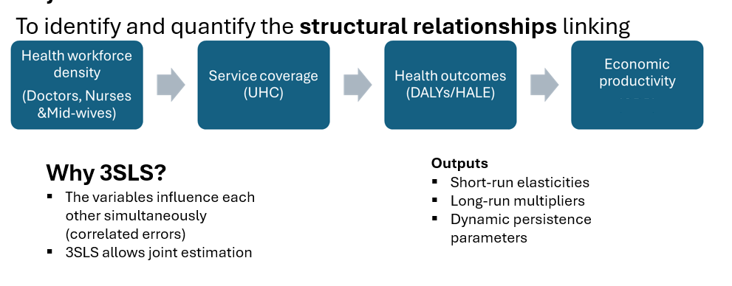
Figure 7: 3SLS modelling framework

Methods
The 3SLS system jointly estimates structural equations with correlated errors:
UHC dynamics equation
$${\text{UHC}}_{t}=f({\text{UHC}}_{t-1},{\text{Doctors}}_{t},{\text{Nurses}}_{t},{\text{GDP}}_{t})$$

Disease burden equation (DALYs):
$$log⁡({\text{DALYs}}_{t})=f({\text{DALYs}}_{t-1},{\text{UHC}}_{t},{\text{GDP}}_{t})$$
Productivity equation:
$$log⁡({\text{Productivity}}_{t})=f({\text{Productivity}}_{t-1},{\text{DALYs}}_{t},{\text{HALE}}_{t})$$
Outputs include short-run elasticities, long-run multipliers, and dynamic persistence parameters.
Results
UHC dynamics
- Lagged UHC = 0.962 (p < 0.001) → UHC changes slowly over time.
- Nursing & midwifery = 0.031 (p = 0.04) → expansion significantly improves service coverage.
- Doctors = 0.030 (p = 0.413) → less influential in short-run UHC expansion.
- GDP = −0.080 (p = 0.70) → not directly driving UHC.
Disease burden (DALYs):
- Lag DALYs = 0.98 (p < 0.001) → extremely persistent.
- UHC = 0.00019 (p = 0.07) → no immediate reduction in DALYs.
- GDP = 0.0034 (p = 0.017) → slight increase in DALYs.
Productivity:
- Lag productivity = 0.986 (p < 0.001) → highly persistent.
- DALYs = 0.134 (p = 0.026) → disease burden significantly reduces productivity.
- HALE = −0.014 (p = 0.31) → not significant.
Punchlines
- “Nurses and midwives drive UHC gains more than doctors” – coefficient 0.031 (p=0.04) vs 0.030 (p=0.413).
- “Disease burden reduction is gradual, not immediate” – UHC coefficient 0.00019 (p=0.07).
- “DALYs are the main channel linking health to productivity” – DALYs coefficient 0.134 (p=0.026) on productivity.
- “Workforce gaps have measurable macroeconomic consequences” – each unit increase in DALYs reduces productivity by 0.134%.
Conclusion and Recommendations
The 3SLS model demonstrates that health workforce expansion, particularly nursing and midwifery, is critical for UHC gains, while disease burden reduction requires sustained investment. Productivity losses due to DALYs highlight the economic imperative of health system strengthening.
Recommendations
- Prioritise nursing and midwifery expansion.
- Integrate disease burden reduction into workforce planning.

Study 7: Health Workforce Coverage and Gap Analysis for Countries in the African Region
Introduction: Health workforce shortages remain a critical barrier to achieving UHC. Many African countries lack reliable and comparable estimates of workforce requirements over time. This study develops transparent projection tools to quantify workforce gaps and test alternative policy scenarios, offering evidence-based insights for planning and resilience.

Main Objective: To develop models that quantify health workforce supply, demand, and return on investment, while identifying coverage gaps under different policy scenarios up to 2035.
The analytics were country specific under the following objectives:
Specific Objectives
- Define workforce requirements using benchmark (normative density) and need-linked (burden-adjusted) models.
- Project workforce supply dynamics based on cadre-specific growth rates, recruitment, and attrition.
- Compare coverage ratios and gaps across cadres and countries under BAU, Scale-Up, and Shock scenarios.
- Highlight cadre distribution gaps that persist even when overall workforce coverage improves.
- Assess resilience/shock and policy impact by quantifying how different scenarios influence time to close workforce gaps.
Methods
Benchmark requirement model – For each cadre $c$, a target workforce density per 10,000 population $B_{c}$ is specified:
$$R_{c,t}^{\text{bench}}=\frac{B_{c}⋅P_{t}}{10,000}$$
Need-linked requirement model – Adjusts for disease burden and health system indicators.
Step 1 – Standardisation:
$$Z_{x,t}=\frac{X_{t}-μ_{x}}{σ_{x}}$$
Composite need index:
$${\text{NI}}_{t}=0.25Z_{\text{DALY},t}+0.25Z_{\text{MMR},t}+0.25Z_{\text{NCD},t}-0.25Z_{\text{UHC},t}$$
Step 2 – Total required density:
$$D_{t}=B_{\text{base}}⋅(1+α⋅{\text{NI}}_{t})$$
Step 3 – Convert to stock:
$$R_{t}^{\text{NL}}=\frac{D_{t}⋅P_{t}}{10,000}$$
Step 4 – Allocate across cadres with shares: Doctors 0.2, Nurses 0.7, Pharmacists 0.07, Dentists 0.03.
Supply dynamics:
$$S_{c,t}=S_{c,t-1}(1+g_{c})$$
Scenarios (BAU, Scale-Up, Shock) modify $g_{c}$.
Coverage and gap metrics:
$${\text{Coverage}}_{c,t}=\frac{S_{c,t}}{R_{c,t}},{\text{Gap}}_{c,t}=S_{c,t}-R_{c,t}$$
Results
- Coverage generally improves over time, especially under Scale-Up scenarios.
- Coverage remains uneven across cadres, with persistent shortages among dentists and pharmacists.
- South Africa shows relative adequacy for several cadres, while Burkina Faso and Guinea-Bissau reveal deeper gaps.
- Need-linked requirements often produce larger shortfalls than benchmark targets.
Punchlines
- “Scale-Up narrows gaps, Shock widens them” – resilience depends on proactive investment.
- “Dentists and pharmacists are the hidden bottleneck” – consistently under-covered across all scenarios.
- “Need-linked models reveal the true depth of shortages” – benchmark alone underestimates the challenge.
- “South Africa demonstrates that adequacy is possible, but uneven distribution remains the Achilles’ heel.”

Conclusion and Recommendations
While workforce coverage can improve with accelerated training and retention, cadre distribution gaps persist and shortages are more severe when adjusted for population health needs.
Recommendations:
- Prioritise Scale-Up policies to accelerate training, recruitment, and retention.
- Address cadre-specific shortages, especially dentists and pharmacists.
- Integrate burden-adjusted models into national HRH planning.
- Strengthen data systems for workforce and burden indicators.
- Adopt resilience-focused strategies to mitigate shocks.

Synthesis: Convergence Across Studies and the Main Message
What Converges?
Across the seven modelling studies - spanning gap analysis, econometric systems, portfolio optimisation, financing allocation, and threshold regressions - several major findings converge:
Table 5: Convergence of the studies
Theme | Convergence Evidence
- Nurses and midwives are the most impactful cadres | Study 1 (UHC elasticity +0.151), Study 6 (3SLS coefficient 0.031, p=0.04), Study 4 (61 nurses/midwives needed for MMR reduction), Study 5 (nurses dominate optimal portfolios)
- Community health workers (CHVs) are high-value in fragile and community-first systems | Study 5 (DRC 0.4285, Rwanda 0.4237 of 70% budget to CHVs); Study 7 (CHVs buffer against clinical shortages)
- Government health financing is the most powerful determinant of system performance | Study 2 (67% government share yields +12.5 years LE, −414 MMR); Study 3 (threshold $74.31 per capita); Study 1 (GGHED positive on LE)
- Workforce effects are delayed and persistent | Study 3 (peak lag at 4 years, coefficient 0.1114); Study 1 (lagged UHC coefficient 0.904); Study 6 (lagged DALYs 0.98)
- Diminishing returns exist for both financing and workforce density | Study 3 (beyond $74.31, effect drops from 0.40 to 0.06); Study 4 (thresholds: 31 doctors, 61 nurses, etc.)
- Country-specific tailoring is essential | Study 5 (optimal nurse share 0.224–0.624); Study 7 (gaps vary widely); Study 2 (optimal mixes differ by outcome)
- Reallocation can yield gains without new funding | Study 5 (MPT efficiency gains); Study 2 (optimising CHE composition); Study 7 (Scale-Up vs BAU)

The following are the deductions form the study convergence points, above, and the details can be found in Appendix 2
- Convergence statement: Nurses, midwives, and community health workers are the backbone of cost-effective health systems. Investing in these cadres yields the highest marginal returns for UHC and maternal health.

- Convergence statement: Government-led, domestic financing is the most effective lever for improving population health and workforce strength. The tipping point is a 67% government share of total health expenditure.

- Convergence statement: More is not always better. Policy should target specific thresholds – $74 per capita government health spending, and cadre-specific density ceilings – to avoid wasteful investment beyond the point of diminishing returns.

- Convergence statement: Health workforce planning must adopt a long-term horizon (4–10 years). Short-term shocks (e.g., budget cuts, attrition spikes) have persistent negative effects that are not quickly reversed.

- Convergence statement: National HRH strategies must be tailored to local disease burden, fiscal space, and existing workforce composition. Regional benchmarks can guide but not prescribe.

- Convergence statement: Before seeking new funding, countries should first reallocate existing budgets toward the most cost-effective cadres and financing sources. Efficiency gains alone can accelerate UHC progress by years.

- Convergence statement: Health workforce investments are not just health expenditures – they are macroeconomic investments. Every DALY averted yields measurable gains in national productivity.

Final punchline for the chapter:
“The modelled operating environment for HRH in Africa is one of delayed returns, diminishing thresholds, and strong persistence. Success does not come from more - it comes from smarter allocation: more government financing, more nurses and CHVs, and more country-specific targeting. When these converge, UHC becomes achievable without additional fiscal burden.”

5.0 POLICY TOOLS AND KNOWLEDGE PRODUCTS DEVELOPMENT

SRHR Workforce Planning Dashboard
We developed prototype interactive dashboards for each of the studies to aid in the analytics, and we display samples of the dashboards:

Study 1: Health Workforce and Financing Dynamics
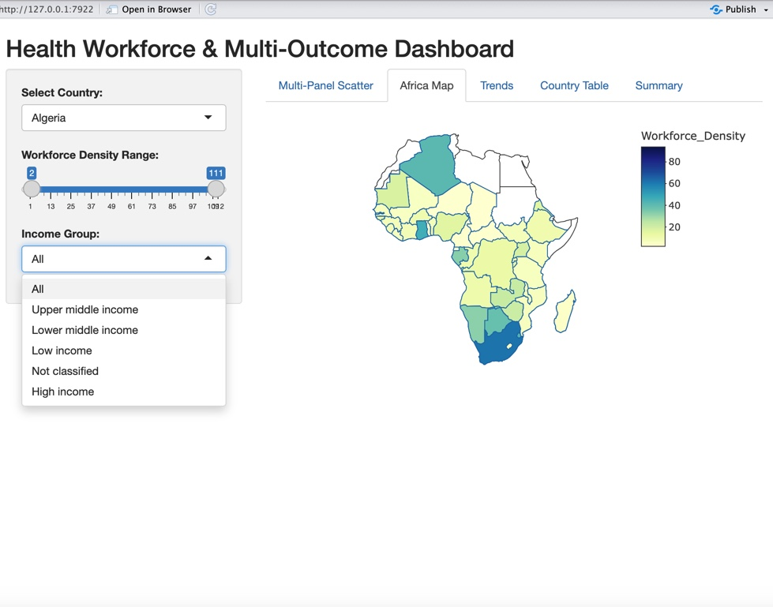

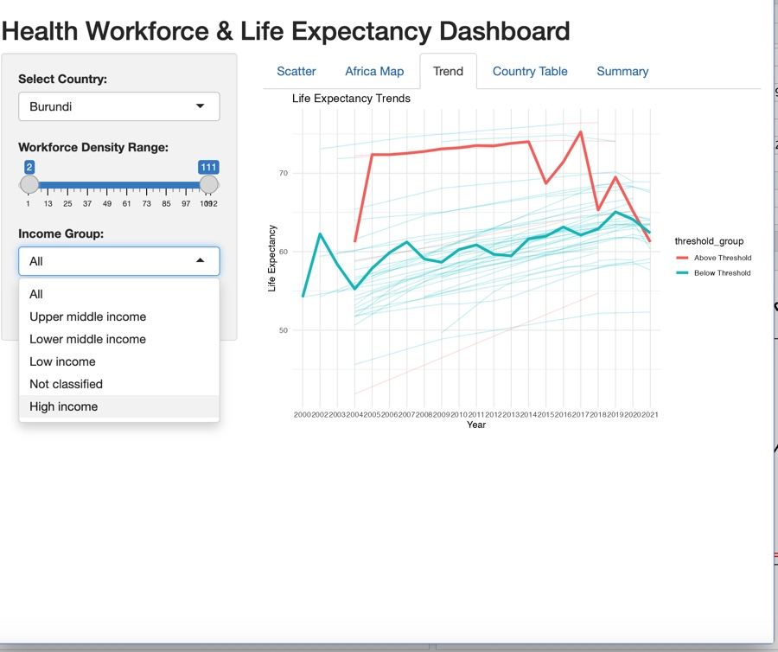

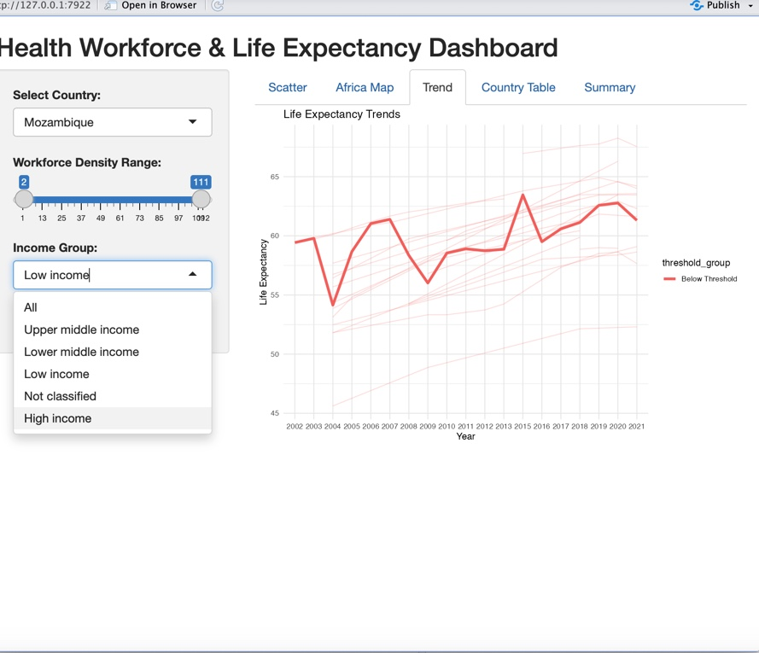

Study 2 - 4: Investing in Health Systems
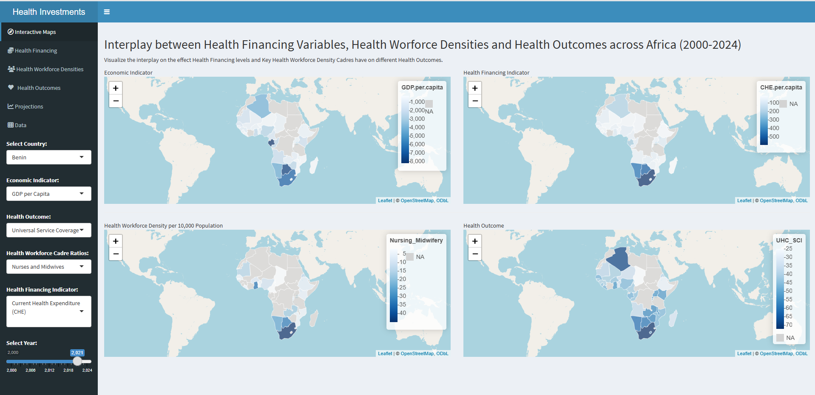

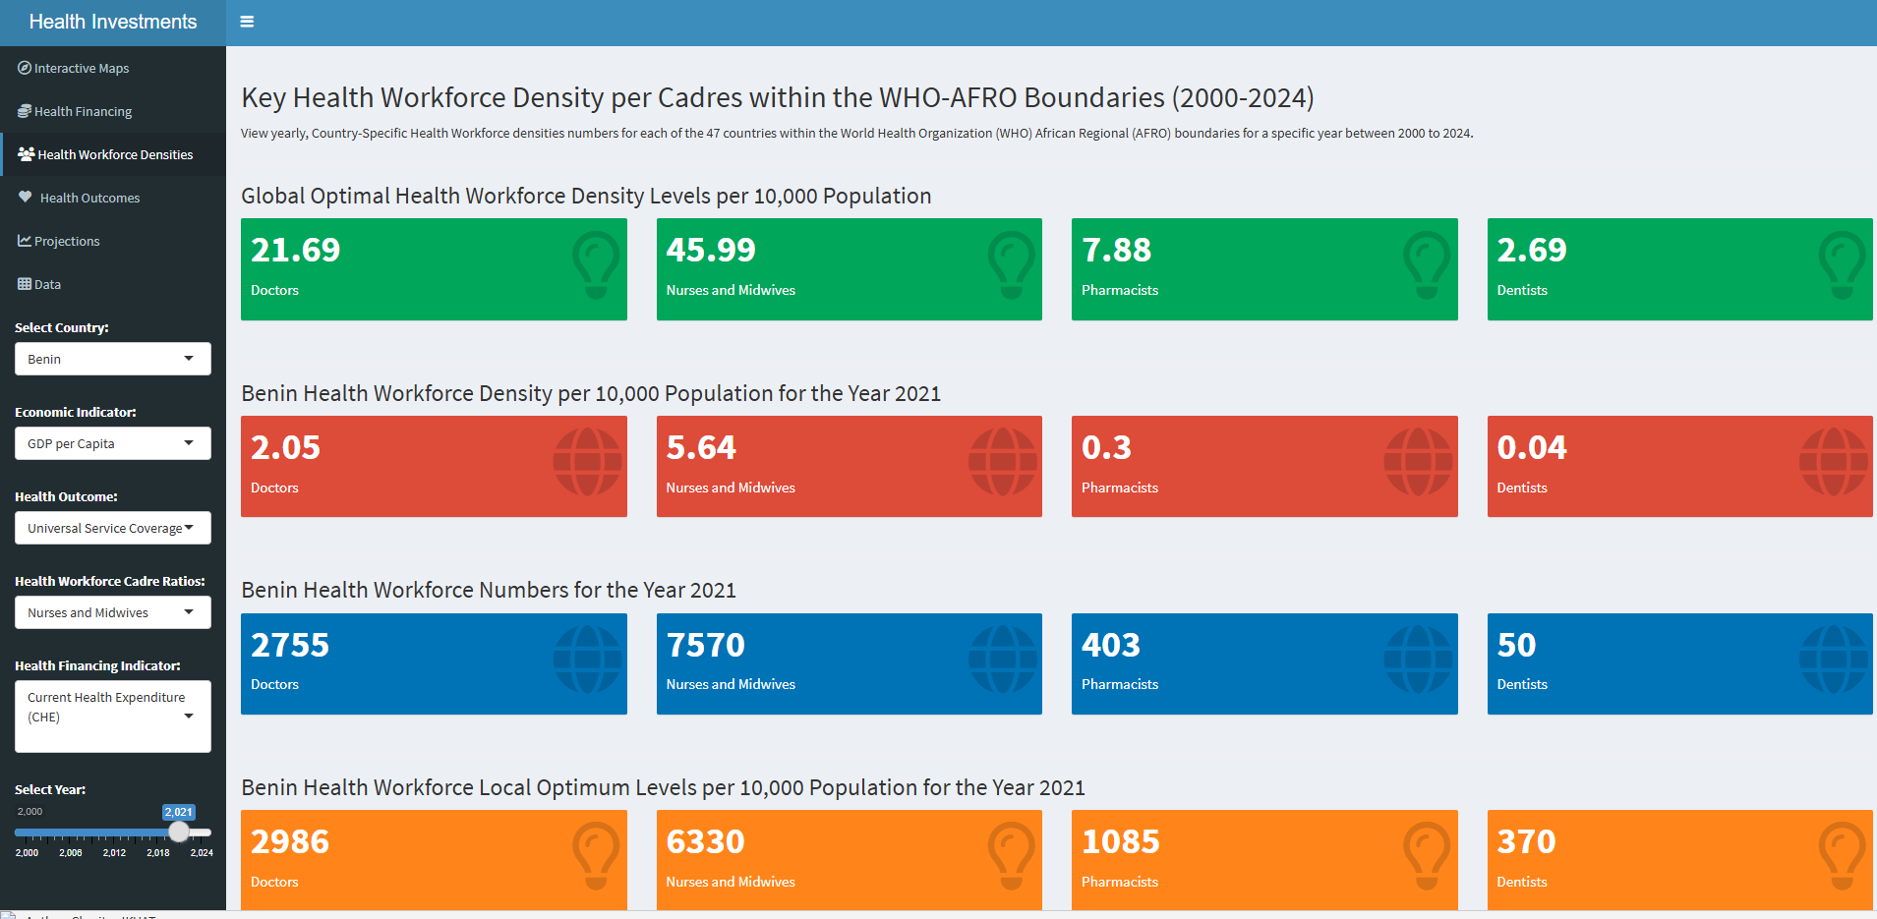

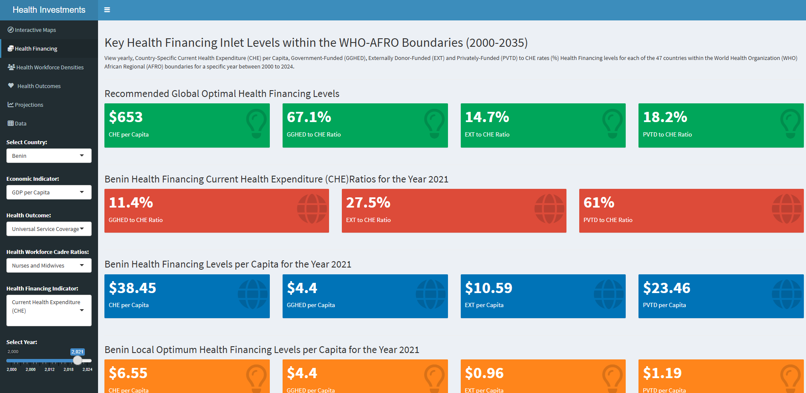

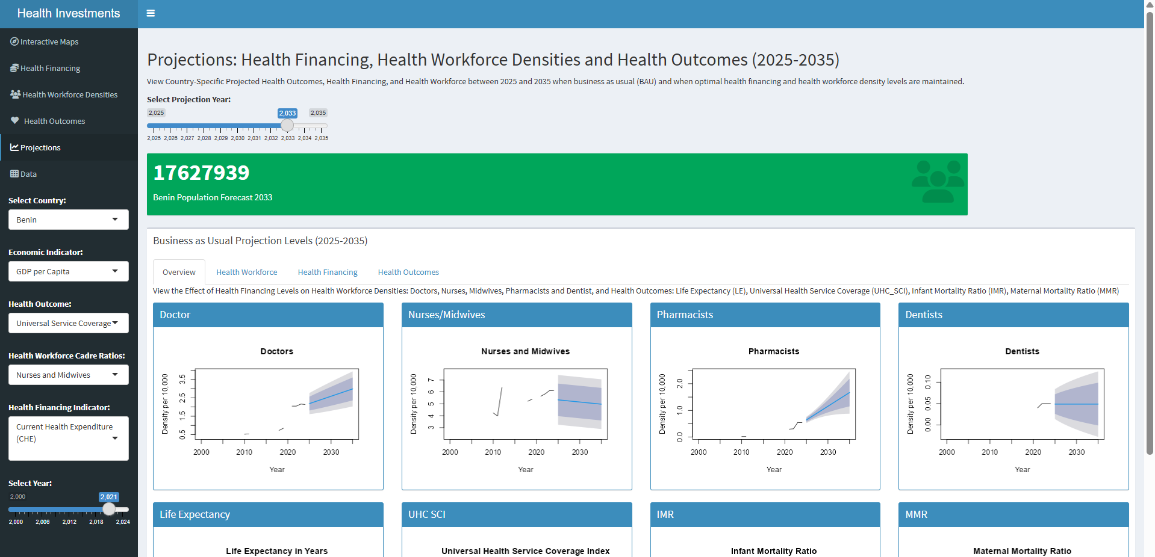

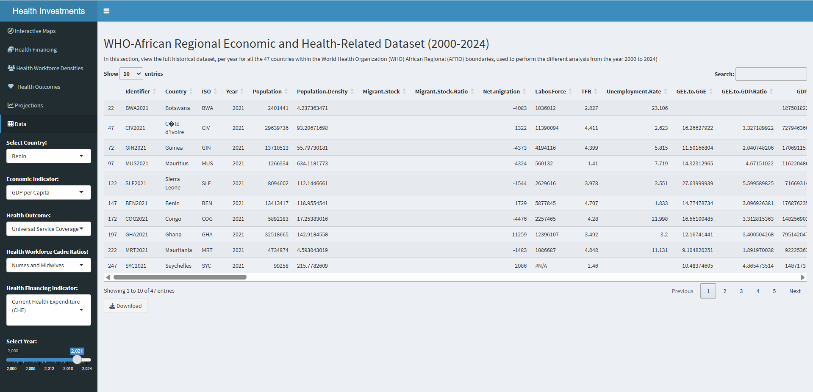

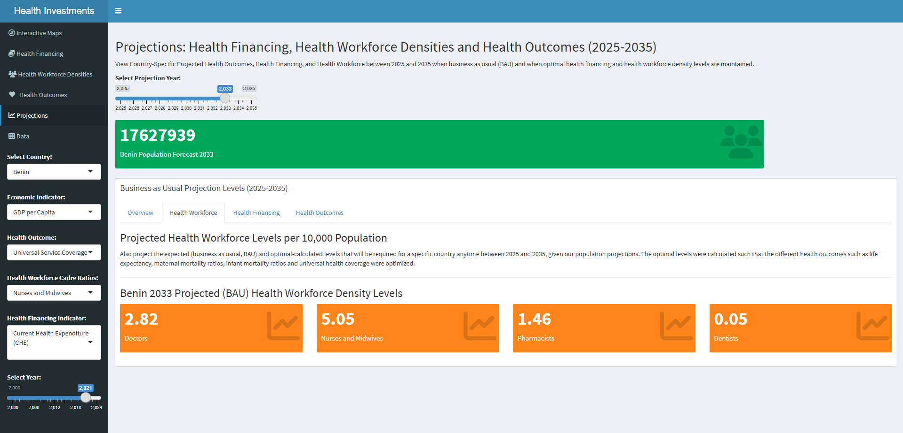

Study 5: Optimizing the Health Workforce Skill-Mix Using Modern Portfolio Theory

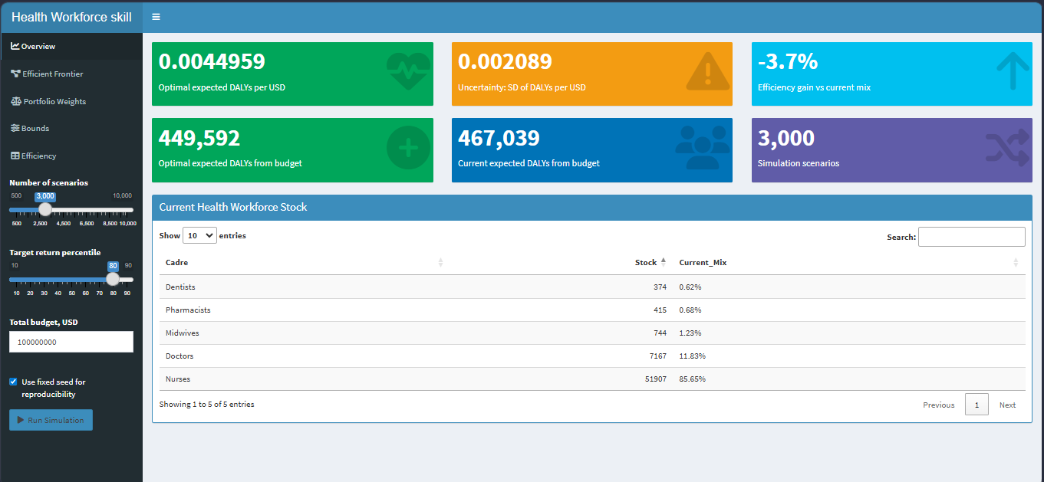

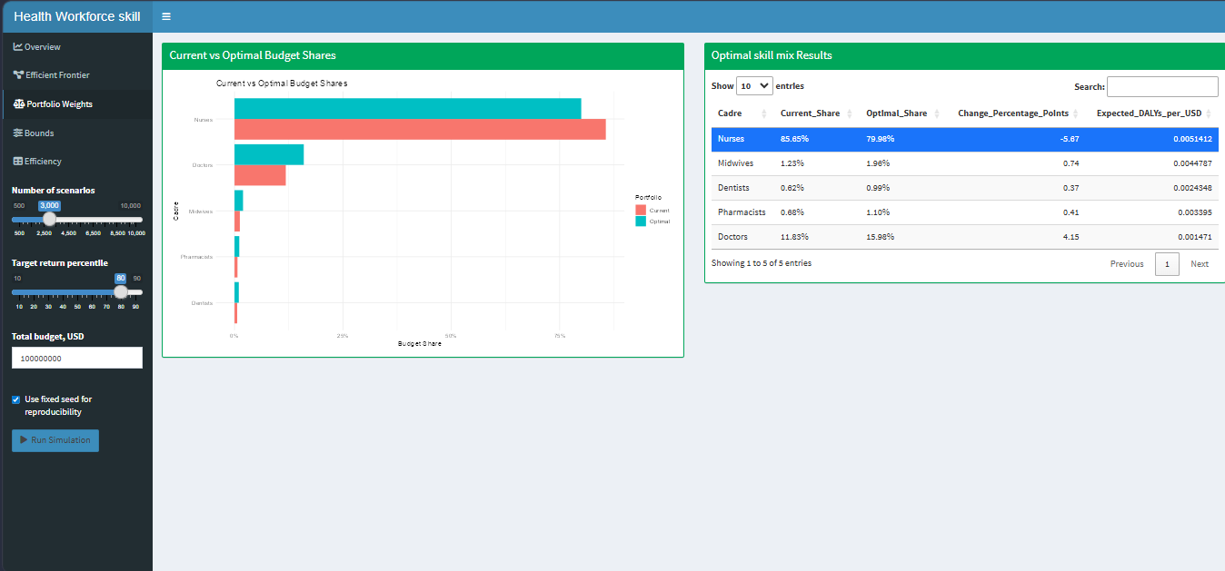

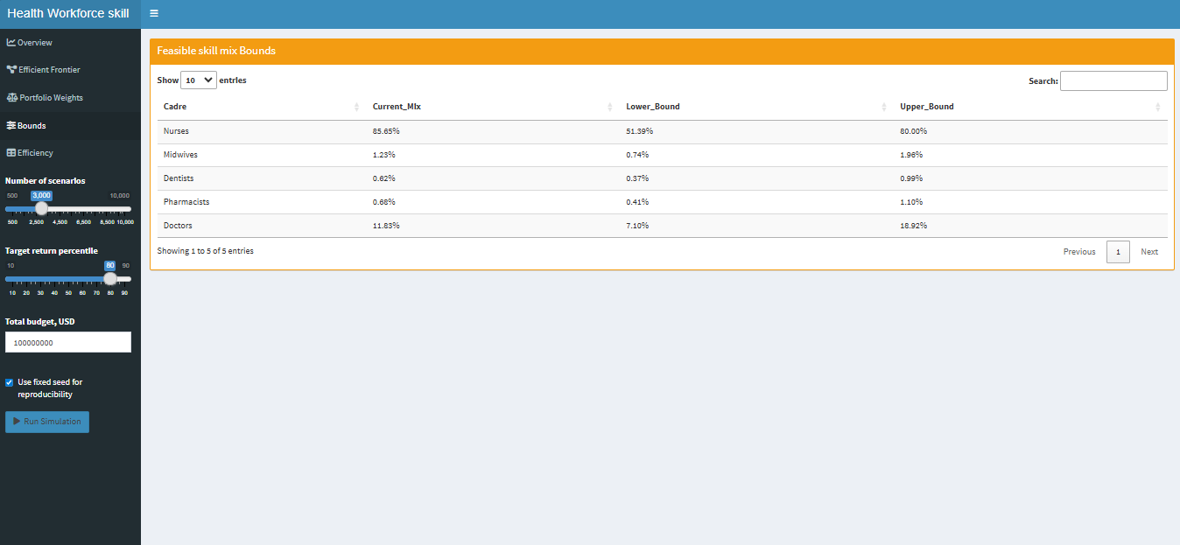

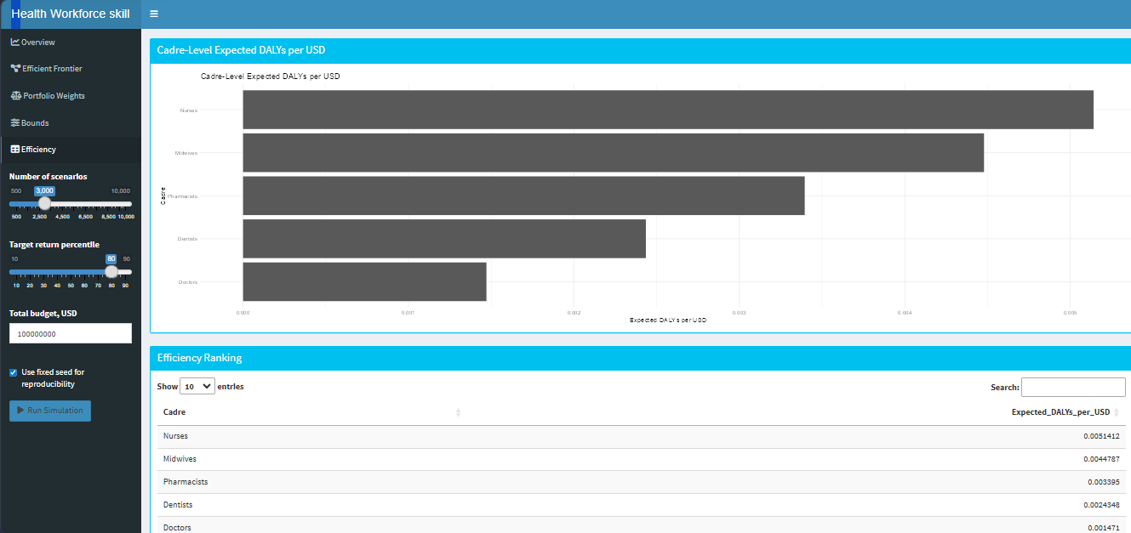

Study 6: Structural Pathways from Health Workforce to Productivity

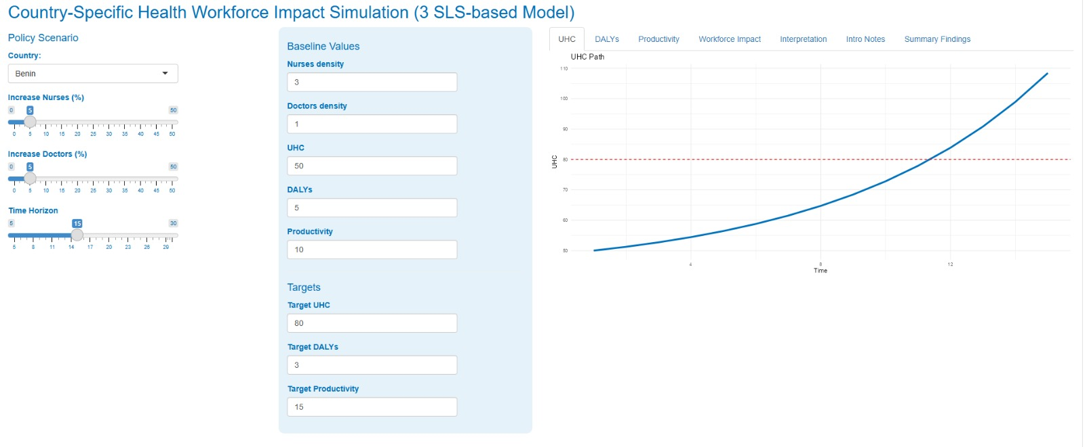

Study 7: Health Workforce Coverage and Gap Analysis
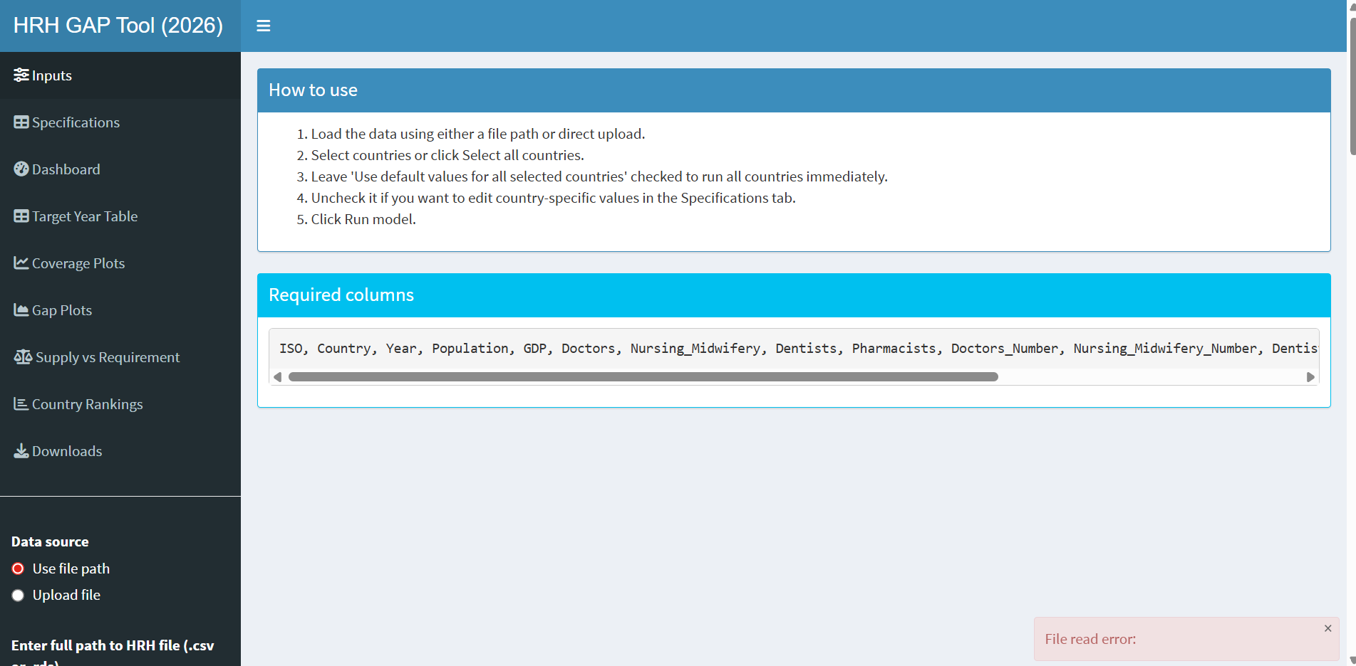
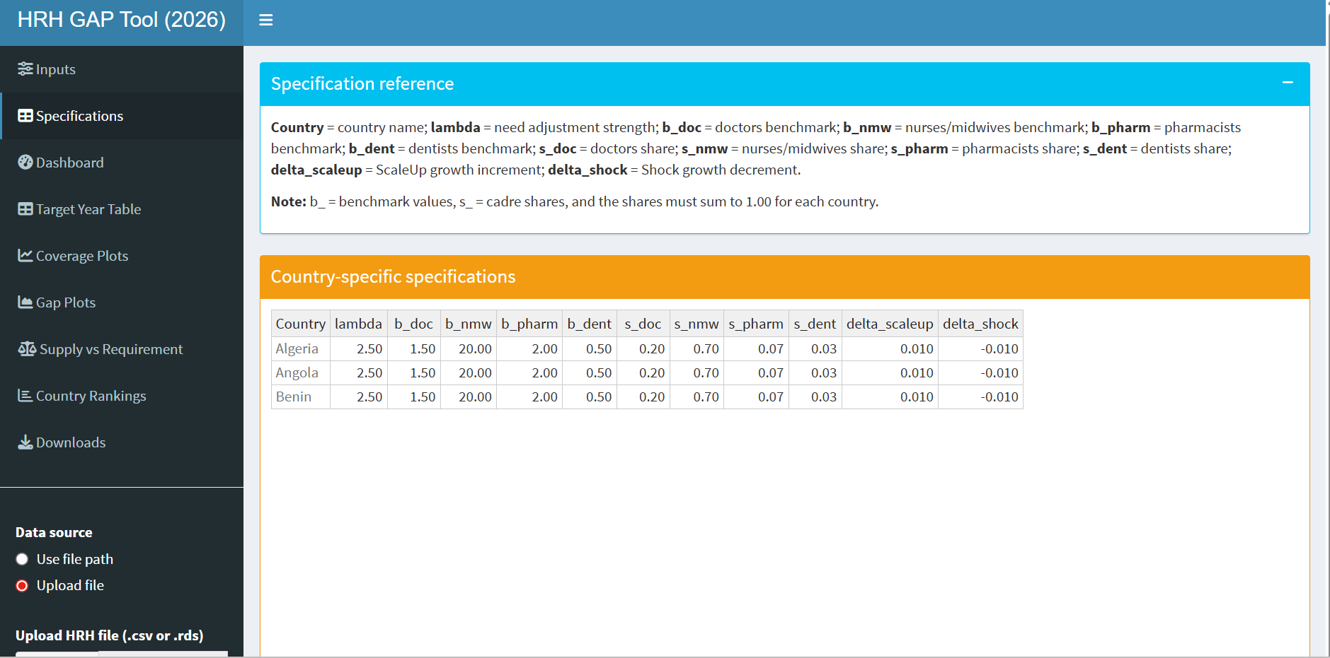
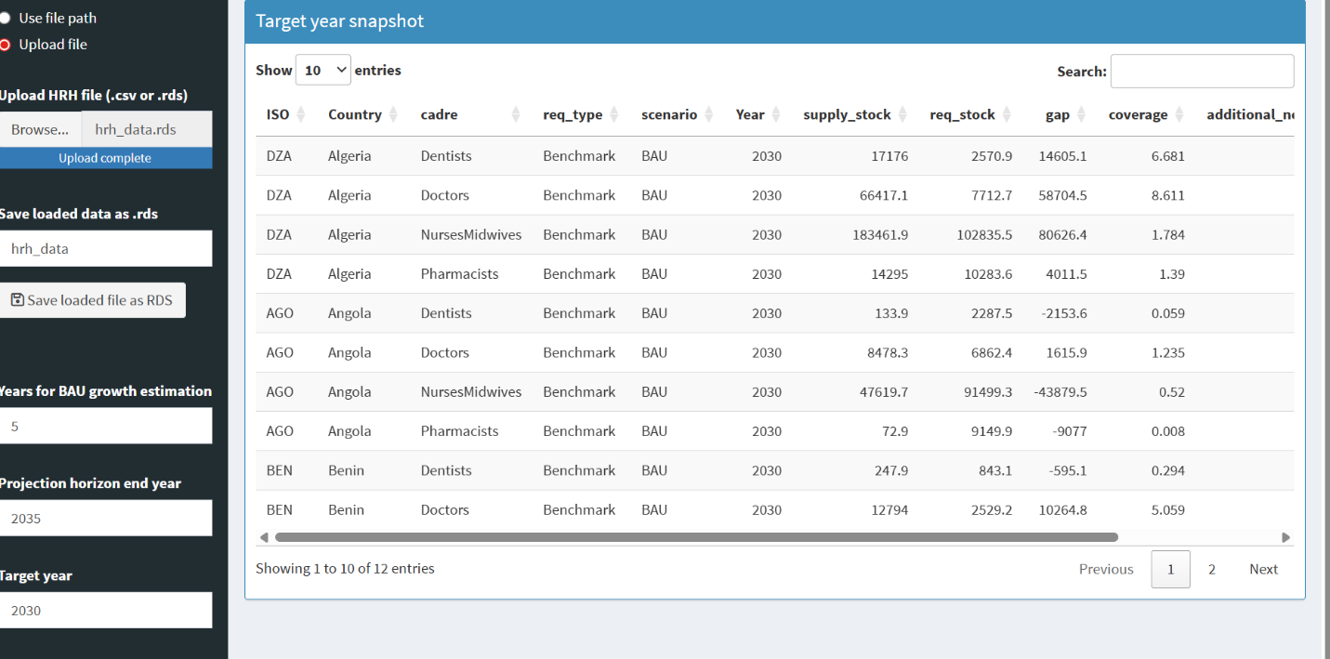
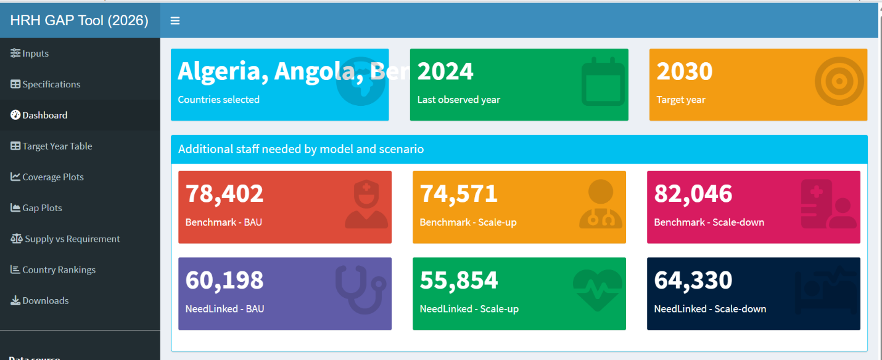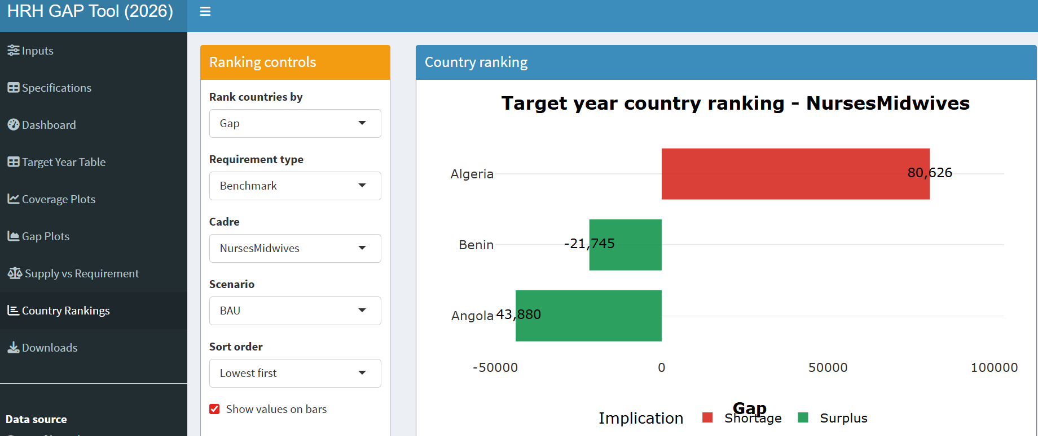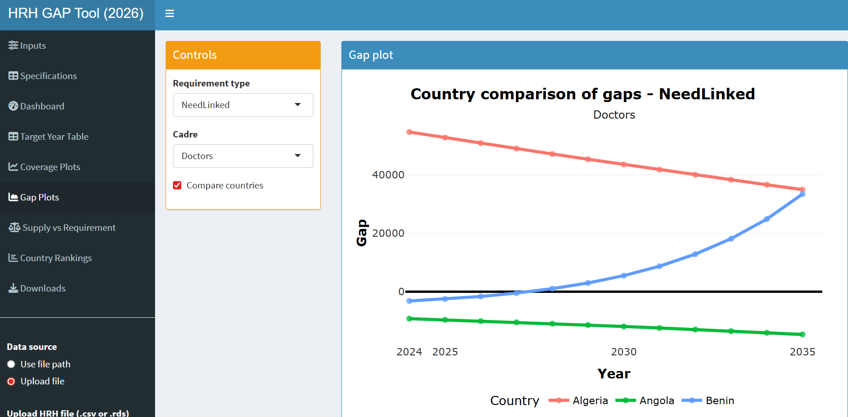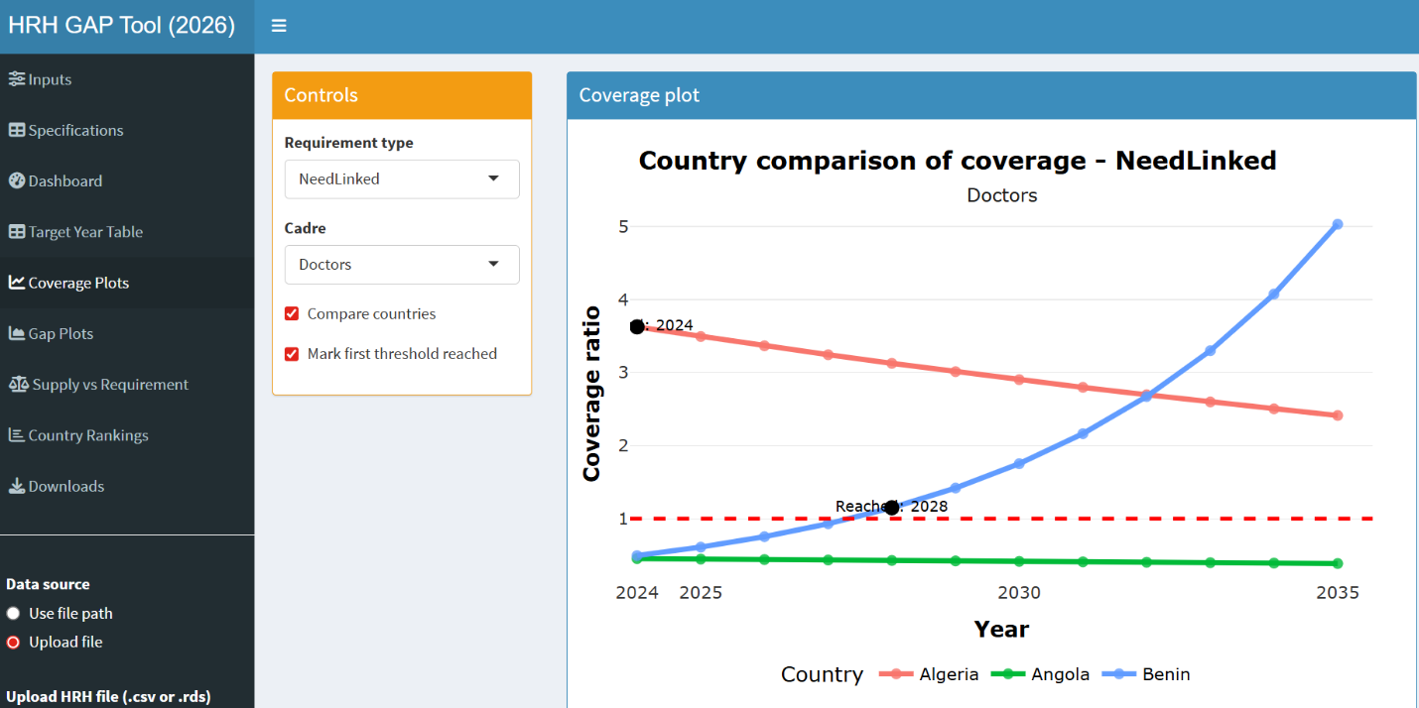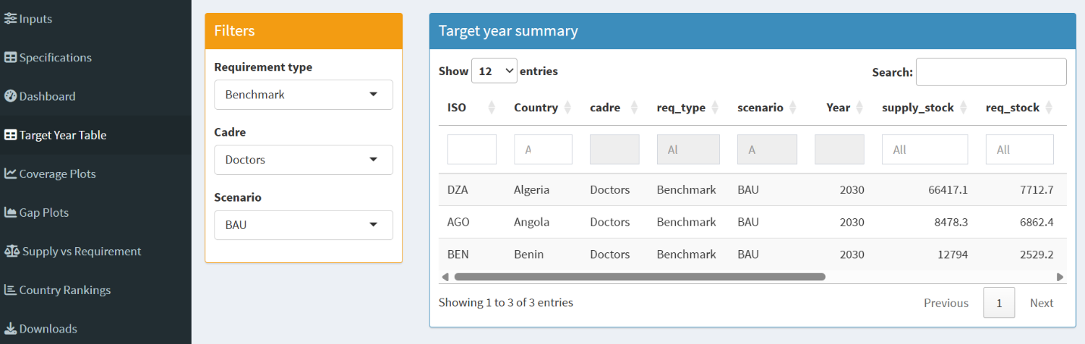

Training materials will be provided for each of these dashboards. For sustainability, Open source software R was used.

6.0 CONCLUSION AND RECOMMENDATIONS

The SRHR workforce challenge in Africa is substantial but not insurmountable. Our analysis demonstrates that with strategic, evidence-based investments focusing on the most cost-effective interventions, significant progress can be made toward ensuring that every woman and adolescent in Africa has access to quality SRHR services provided by a competent, motivated, and equitably distributed health workforce.
The tools and frameworks we have developed provide a roadmap for this transformation. By combining rigorous analysis with practical policy tools and capacity building, we can support African countries in building the SRHR workforce needed to achieve the Sustainable Development Goals and ensure sexual and reproductive health and rights for all.

7.0 FUTURE ENGAGEMENTS IN THE NETWORK OF PARTNERS FOR JKUAT

- Continuous updating and validation of the modelling approaches
- Propose new metadata to be incorporated over time
- Microplanning models using case specific scenarios
- Dissemination of the results
- Training on implementation and adoption of the developed HRH management tools
- Establish a training centre on HRH manpower planning in the African region
- Continued collaboration with the network of partners
- Participation in data collection and collation in the region

ACKNOWLEDGMENTS
We gratefully acknowledge the support and collaboration of WHO AFRO, particularly the Reproductive and Maternal Health Unit and the Health Workforce Unit. We thank our partners at NWU and AFRiHealth for their valuable contributions. We appreciate the inputs from ministry officials and experts in our focus countries.

Report Prepared by:
JKUAT Health Workforce Modelling Team
WHO Network of Partners for SRHR Workforce Development

JKUAT team:
- Prof Anthony Waititu, Dean School of Mathematical and Physical Sciences (SMPS)
- Dr. Charity Wamwea, Chair of the Statistics and Actuarial Sciences Department (STACS)
- Dr. Joseph K. Mung’atu (Statistical modelling, STACS)
- Dr. Jane A. Akinyi (Statistician and health researcher, STACS)
- Dr. Winnie Chacha (financial modeller and statistician, STACS)
- Dr. Ann Omamo (Human Resource Management, JKUAT)
- Mr. Henry Kissinger Ochieng (Statistician, STACS)
- Ms. Caroline W. Mugo (Statistician, STACS)
- Dr. Matabel Odin (Financial Mathematics, STACS)

For more information contact:
Department of Statistics and Actuarial Sciences
Jomo Kenyatta University of Agriculture and Technology (JKUAT)
P.O Box 62000
00200
Nairobi, Kenya
stacs@fsc.jkuat.ac.ke

Bibliography

African Forum for Research and Health (AfHRH). (2023). Transforming Africa’s health workforce: A policy brief on education standards and leadership.
Ahmat, A., Asamani, J. A., Illou, M. M. A., Millogo, J. J. S., Okoroafor, S. C., Nabyonga-Orem, J., … & Nyoni, J. (2022). Estimating the threshold of health workforce densities towards universal health coverage in Africa. BMJ Global Health, 7(Suppl 1), e008310.
Asamani, J. A., Bediakon, K. S. B., Boniol, M., Munga’tu, J. K., Christmals, C. D., Okoroafor, S. C., … & Moeti, M. R. (2024). State of the health workforce in the WHO African Region: Decade review of progress and opportunities for policy reforms and investments. BMJ Global Health, 7(Suppl 1), e015952. https://doi.org/10.1136/bmjgh-2024-015952
Boniol, M., Kunjumen, T., Nair, T. S., Siyam, A., Campbell, J., & Diallo, K. (2022). The global health workforce stock and distribution in 2020 and 2030: A threat to equity and ‘universal’ health coverage? BMJ Global Health, 7(6), e009316. https://doi.org/10.1136/bmjgh-2022-009316
Borgen Project. Health care in Congo. https://borgenproject.org/health-care-in-congo/
Campbell, J., Dussault, G., Buchan, J., Pozo-Martin, F., et al. (2013). A universal truth: No health without a workforce. Global Health Workforce Alliance & WHO.
Creswell, J. W., & Plano Clark, V. (2017). Designing and conducting mixed methods research (3rd ed.). Sage Publications.
Di Giorgio, L., Evans, D. K., Lindelow, M., Nguyen, S. N., Svensson, J., Wane, W., & Welander Tärneberg, A. (2020). Analysis of clinical knowledge, absenteeism and availability of resources for maternal and child health: A cross-sectional quality of care study in 10 African countries. BMJ Global Health, 5(12), e003377. https://doi.org/10.1136/bmjgh-2020-003377
Generis Online. An overview of the healthcare system in Congo Brazzaville. https://generisonline.com/an-overview-of-the-healthcare-system-in-congo-brazzaville/
Ghana Infrastructure Investment Fund. (2023). Ghana’s healthcare sector report. https://www.gipc.gov.gh/wp-content/uploads/2023/03/Ghanas-Healthcare-Sector-Report.pdf
International Labour Organization (ILO). (2017). Resolution on improving employment and working conditions in health services.
Ministry of Health, Ethiopia. (2025). *Human resources for health strategic and investment plan (HRHSIP) for Ethiopia, 2024-2030*. https://www.moh.gov.et/sites/default/files/2025-05/Human%20Resources%20for%20Health%20Strategic%20and%20Investment%20Plan%20%28HRHSIP%29%20for%20Ethiopia%2C%202016-20222024-2030.pdf
Ministry of Health, Eswatini. Final policy brief on health workforce in Eswatini. https://files.aho.afro.who.int/afahobckpcontainer/production/files/Final__Policy_Brief_on_Health_Workforce_in_Eswatini_.pdf
Ministry of Health, Eswatini. Final human resources for health (HLMA) report – Eswatini. https://files.aho.afro.who.int/afahobckpcontainer/production/files/Final_HLMA_Report_Eswatini_Signed_and_Launched.pdf
Ministry of Health, Eswatini. (2025). National health strategic plan (NHSSP) – Eswatini. https://www.afro.who.int/sites/default/files/2025-02/NHSSP%20ESWATINI%20.pdf
Ministry of Health, Eswatini. (2025). Annual report of the Ministry of Health 2025. Parliament of Eswatini. https://parliament.gov.sz/publications/parliament_reports/docs/ANNUAL%20REPORT%20HEALTH%202025.pdf
Ministry of Health, Rwanda. *Health budget brief 2022-2023*. UNICEF. https://www.unicef.org/rwanda/media/4606/file/Health-Budget-Brief-2022-2023.pdf
Ministry of Health, Rwanda. Rwanda health labour market analysis (HLMA) report. https://files.aho.afro.who.int/afahobckpcontainer/production/files/Rwanda_HLMA_Report.pdf
Ministry of Health, Seychelles. (2022). *National health strategic plan 2022-2026*. https://www.health.gov.sc/national-health-strategic-plan-2022-2026-2/strategic-direction-five-invest-for-results/
Ministry of Health, Seychelles. (2022). MOH annual performance report 2022. https://www.health.gov.sc/wp-content/uploads/2024/05/MOH-Annual-Performance-Report-2022.pdf
Nonet, G. A.-H., Gössling, T., Van Tulder, R., & Bryson, J. M. (2022). Multi-stakeholder engagement for the Sustainable Development Goals: Introduction to the special issue. Journal of Business Ethics, 180(4), 945–957. https://doi.org/10.1007/s10551-022-05192-0
Population Reference Bureau. (2022). *Plan de développement du secteur santé 2020-2024* [Health sector development plan 2020-2024]. https://scorecard.prb.org/wp-content/uploads/2022/03/Plan-de-de%CC%81veloppement-du-secteur-sante%CC%81-2020-2024..pdf
Scheffler, R. M., Liu, J. X., Kinfu, Y., & Dal Poz, M. R. (2008). Forecasting the global shortages of physicians: An economic- and needs-based approach. Bulletin of the World Health Organization, 86(7), 516-523.
United Nations Population Fund (UNFPA). (2022). State of the world population report: Seeing the unseen – The case for action in the neglected crisis of unintended pregnancy.
UN High-Level Commission on Health Employment and Economic Growth. (2016). Working for health and growth: Investing in the health workforce. WHO, ILO, OECD.
United Nations Statistics Division. Statistical yearbook. https://unstats.un.org/UNSDWebsite/Publications/StatisticalYearbook/
UNICEF Ethiopia. (2024). National health budget brief 2024. https://www.unicef.org/ethiopia/media/10596/file/National%20Health%20Budget%20Brief%202024.pdf.pdf
World Health Organization (WHO). (2006). The world health report 2006: Working together for health.
World Health Organization (WHO). (2010). Workload indicators of staffing need (WISN): User’s manual.
World Health Organization (WHO). (2012). Roadmap for scaling up the human resources for health for improved health service delivery in the African Region 2012–2025 (AFR/RC62/7).
World Health Organization (WHO). (2016). Global strategy on human resources for health: Workforce 2030.
World Health Organization (WHO). (2023). National health workforce accounts: A handbook (2nd ed.). CC BY-NC-SA 3.0 IGO.
World Health Organization (WHO). (2023). Global health observatory: Health workforce statistics. https://www.who.int/data/gho
World Health Organization (WHO). (2024). *Congo country profile – WHO results report 2022-2023*. https://www.who.int/about/accountability/results/who-results-report-2022-2023/country-profile/2023/congo
World Health Organization (WHO). (2025). Maternal mortality. https://www.who.int/news-room/fact-sheets/detail/maternal-mortality
World Health Organization (WHO). (2025). World health statistics 2025: Monitoring health for the SDGs, Sustainable Development Goals.
World Health Organization (WHO). Global health workforce statistics – National health workforce accounts. https://www.who.int/data/gho/data/themes/topics/health-workforce
World Health Organization (WHO). *Benin human resources for health plan 2009-2018*. https://extranet.who.int/countryplanningcycles/sites/default/files/country_docs/Benin/benin_hrh_2009-2018.pdf
World Health Organization (WHO). Data by country – Seychelles. https://data.who.int/countries/690
World Health Organization (WHO). Global health observatory. https://www.who.int/data/gho
World Health Organization (WHO). RDC plan national de développement sanitaire (PNDS) 2022. https://p4h.world/app/uploads/2024/07/RDC_PNDS_2022.x69485.pdf
World Health Organization Regional Office for Africa (WHO AFRO). (2022a). Regional strategy on human resources for health 2022–2030: Health workforce accelerating progress towards universal health coverage and the SDGs in the WHO African Region.
World Health Organization Regional Office for Africa (WHO AFRO). (2022b). The state of the health workforce in the WHO African Region: Evidence for action.

Appendices

Appendix 1: Optimal allocations from the MPT study (Study 5)
Country | Nurses | Midwives | Dentists | Pharmacists | Doctors | CHVs
Algeria | 0.335 | 0.047 | 0.083 | 0.070 | 0.165 | -
Angola | 0.559 | 0.014 | 0.007 | 0.008 | 0.112 | 0.000
Benin | 0.278 | 0.114 | 0.001 | 0.011 | 0.043 | 0.254
Botswana | 0.559 | 0.014 | 0.007 | 0.008 | 0.112 | 0.000
Burkina Faso | 0.276 | 0.246 | 0.005 | 0.036 | 0.038 | 0.098
Burundi | 0.379 | 0.020 | 0.000 | 0.000 | 0.023 | 0.278
Cabo Verde | 0.624 | 0.027 | 0.012 | 0.006 | 0.212 | 0.119
Cameroon | 0.280 | 0.039 | 0.006 | 0.055 | 0.114 | 0.206
Central African Republic | 0.266 | 0.197 | 0.000 | 0.002 | 0.024 | 0.212
Chad | 0.285 | 0.090 | 0.000 | 0.004 | 0.050 | 0.270
Comoros | 0.341 | 0.272 | 0.015 | 0.025 | 0.082 | 0.266
Congo (Republic of the Congo) | 0.399 | 0.191 | 0.033 | 0.004 | 0.145 | 0.229
Côte d’Ivoire | 0.334 | 0.228 | 0.004 | 0.080 | 0.076 | 0.277
Democratic Republic of the Congo | 0.255 | 0.003 | 0.000 | 0.001 | 0.013 | 0.429
Equatorial Guinea | 0.338 | 0.028 | 0.021 | 0.015 | 0.143 | 0.155
Eritrea | 0.523 | 0.013 | 0.013 | 0.043 | 0.025 | 0.385
Eswatini | 0.374 | 0.002 | 0.004 | 0.006 | 0.040 | 0.274
Ethiopia | 0.237 | 0.139 | 0.002 | 0.086 | 0.041 | 0.196
Gabon | 0.411 | 0.144 | 0.007 | 0.030 | 0.091 | 0.017
Gambia | 0.494 | 0.244 | 0.001 | 0.032 | 0.025 | 0.204
Ghana | 0.346 | 0.171 | 0.001 | 0.022 | 0.018 | 0.143
Guinea | 0.281 | 0.048 | 0.002 | 0.011 | 0.061 | 0.298
Guinea-Bissau | 0.320 | 0.024 | 0.000 | 0.000 | 0.028 | 0.329
Kenya | 0.341 | 0.012 | 0.001 | 0.007 | 0.032 | 0.307
Lesotho | 0.303 | 0.091 | 0.001 | 0.005 | 0.012 | 0.288
Liberia | 0.406 | 0.157 | 0.001 | 0.025 | 0.026 | 0.086
Madagascar | 0.238 | 0.114 | 0.006 | 0.000 | 0.024 | 0.319
Malawi | 0.319 | 0.022 | 0.002 | 0.002 | 0.025 | 0.330
Mali | 0.301 | 0.134 | 0.005 | 0.040 | 0.131 | 0.089
Mauritania | 0.166 | 0.165 | 0.041 | 0.026 | 0.182 | 0.120
Mauritius | 0.290 | 0.061 | 0.045 | 0.004 | 0.201 | 0.099
Mozambique | 0.225 | 0.218 | 0.012 | 0.014 | 0.071 | 0.162
Namibia | 0.272 | 0.264 | 0.014 | 0.033 | 0.040 | 0.078
Niger | 0.503 | 0.139 | 0.002 | 0.005 | 0.042 | 0.009
Nigeria | 0.235 | 0.166 | 0.003 | 0.051 | 0.052 | 0.193
Rwanda | 0.224 | 0.031 | 0.002 | 0.007 | 0.013 | 0.424
Sao Tome and Principe | 0.399 | 0.067 | 0.016 | 0.100 | 0.118 | -
Senegal | 0.098 | 0.053 | 0.004 | 0.007 | 0.020 | 0.519
Seychelles | 0.303 | 0.229 | 0.013 | 0.088 | 0.068 | 0.000
Sierra Leone | 0.316 | 0.045 | 0.000 | 0.003 | 0.019 | 0.318
South Africa | 0.467 | 0.000 | 0.013 | 0.041 | 0.062 | 0.118
South Sudan | 0.221 | 0.216 | 0.005 | 0.036 | 0.062 | 0.161
Togo | 0.198 | 0.112 | 0.000 | 0.001 | 0.025 | 0.364
Uganda | 0.292 | 0.056 | 0.001 | 0.002 | 0.014 | 0.335
United Republic of Tanzania | 0.323 | 0.000 | 0.004 | 0.040 | 0.056 | 0.278
Zambia | 0.315 | 0.045 | 0.001 | 0.005 | 0.017 | 0.317
Zimbabwe | 0.308 | 0.065 | 0.003 | 0.030 | 0.021 | 0.272

Appendix 2: Evidence for convergence
Expanded Synthesis: Convergence Across All Studies and the Main Message
The seven modelling studies presented in this chapter examine the HRH operating environment from complementary methodological perspectives: workforce gap analysis (Study 7), simultaneous equation systems (Study 6), portfolio optimisation (Study 5), financing allocation non-linearities (Study 2), financing-workforce linkages with thresholds and lags (Study 3), workforce-outcome thresholds (Study 4), and dynamic panel analysis of workforce and financing effects (Study 1). Despite their different data sources, time horizons, and statistical techniques, they converge on a coherent set of findings. Below, each convergence point is elaborated with cross-study evidence.

Convergence 1: Nurses, Midwives, and Community Health Workers Are the Most Impactful Cadres for UHC and Mortality Reduction
What the evidence shows: Across every study that disaggregates cadre effects, nursing, midwifery, and CHW cadres consistently outperform doctors in driving service coverage, reducing maternal mortality, and achieving efficient budget allocation.
- Study 6 (3SLS) – Nursing and midwifery density has a statistically significant positive effect on UHC service coverage (coefficient 0.031, p=0.04), while doctors do not reach significance (0.030, p=0.413).
- Study 1 (Fixed effects dynamic panel) – A 1% sustained increase in nurse and midwife density is associated with a 0.151% long-run improvement in UHC service coverage.
- Study 4 (Threshold analysis) – To rapidly reduce maternal mortality, 61 nurses and midwives per 10,000 population are needed, compared to only 12 doctors. For UHC service coverage, the required density of nurses/midwives (48 per 10,000) is nearly four times that of doctors (13 per 10,000).
- Study 5 (MPT portfolio optimisation) – In the optimal allocation of 70% of the HRH budget across the WHO African region countries, nurses and CHVs absorb the majority of the budget in almost every country. For example, Cabo Verde allocates 62% to nurses, Rwanda allocates 42% to CHVs, and Angola allocates 56% to nurses.
- Study 7 (Gap analysis) – Under Scale-Up scenarios, closing the coverage gap for nurses and midwives yields larger gains in effective coverage than closing the doctor gap, due to their broader deployment in primary care.
Convergence statement: Nurses, midwives, and community health workers are the backbone of cost-effective health systems. Investing in these cadres yields the highest marginal returns for UHC and maternal health.

Convergence 2: Government Health Financing Is the Most Powerful and Sustainable Source of Health System Improvement
What the evidence shows: Public, domestically sourced financing consistently outperforms external donor funding and private expenditure in improving life expectancy, reducing mortality, and building workforce density.
- Study 2 (GAM optimisation) – The optimal composition of current health expenditure across all outcomes averages 67% government, 19% private, 14% external. Countries that achieve >67% government share enjoy:
  - UHC index +26% above regional average
  - Life expectancy +12.5 years above the regional average
  - Maternal mortality −414 per 100,000 live births less than the regional average
  - Infant mortality −34 per 1,000 live births less than the regional average
- Study 5 (GAM regression) – Health workforce increase non-linearly with increasing government expenditure on health.
- Study 1 (Fixed effects) – Government health expenditure per capita is positively associated with life expectancy (+0.0302, p<0.001) in the static model, and remains a significant long-term driver.
- Study 2 (3SLS) – GDP per capita does not directly drive UHC, but government health expenditure (embedded in GGHED) indirectly supports UHC through workforce expansion.
Convergence statement: Government-led, domestic financing is the most effective lever for improving population health and workforce strength. The tipping point is a 67% government share of total health expenditure.

Convergence 3: Thresholds and Diminishing Returns Apply to Both Financing and Workforce Density
What the evidence shows: Beyond certain levels, additional investment yields progressively smaller gains. This finding has profound implications for target setting.
- Study 5 (Financing threshold) – The relationship between government health expenditure per capita and workforce density changes at $74.31 per capita.
  - Below $74.31: each $1 increases density by 0.40 workers per 10,000.
  - Above $74.31: each $1 increases density by only 0.06 workers per 10,000 – a 85% drop in marginal productivity.
- Study 4 (Workforce density thresholds) – Each cadre has a density beyond which further increases do not improve outcomes:
  - Life expectancy plateaus after 31 doctors, 30 nurses/midwives, 3 dentists, 6 pharmacists per 10,000.
  - UHC service coverage plateaus after 13 doctors, 48 nurses/midwives, 4 dentists, 8 pharmacists per 10,000.
  - Maternal mortality reduction plateaus after 12 doctors, 61 nurses/midwives, 3 dentists, 11 pharmacists.
- Study 5 (MPT efficient frontier) – The efficient frontier demonstrates that beyond a certain level of diversification, risk reduction comes at the cost of significantly lower returns, implying an optimal skill-mix that is not simply “more of everything”.
Convergence statement: More is not always better. Policy should target specific thresholds – $74 per capita government health spending, and cadre-specific density ceilings – to avoid wasteful investment beyond the point of diminishing returns.

Convergence 4: Time Lags and Persistence Dominate HRH and Health Outcomes
What the evidence shows: The effects of workforce and financing investments are not immediate. They take years to materialise, and past outcomes strongly predict future outcomes.
- Study 3 (Lagged effects of financing on workforce) – Government health expenditure has its strongest impact on workforce density after four years (coefficient 0.1114). This reflects the time needed to train, deploy, and retain health workers.
- Study 6 (3SLS) – Lagged UHC (0.962, p<0.001) and lagged DALYs (0.98, p<0.001) are extremely persistent. Changes in UHC today will take many years to fully manifest.
- Study 1 (Dynamic panel) – Lagged life expectancy coefficient = 0.9111 (p<0.001); lagged UHC coefficient = 0.904 (p<0.001). This means that over 90% of the variation in current outcomes is explained by past outcomes, leaving little room for short-run workforce effects.
- Study 7 (Gap analysis) – Even under optimistic Scale-Up scenarios, closing workforce gaps for dentists and pharmacists’ takes more than a decade in most countries due to training pipeline lags.
Convergence statement: Health workforce planning must adopt a long-term horizon (4–10 years). Short-term shocks (e.g., budget cuts, attrition spikes) have persistent negative effects that are not quickly reversed.

Convergence 5: Country-Specific Tailoring Is Essential – No Universal Workforce or Financing Mix Exists
What the evidence shows: Optimal allocations vary widely across countries. One-size-fits-all policies will be suboptimal.
- Study 5 (MPT optimal budgets) – The optimal nurse share of the total HRH budget ranges from 0.224 (Rwanda) to 0.624 (Cabo Verde). CHV share ranges from 0.0001 (Angola) to 0.4285 (DRC).
- Study 7 (Coverage gaps) – South Africa has near-adequate workforce density for some cadres, while Burkina Faso and Guinea-Bissau have deep, multi-cadre shortages.
- Study 2 (Optimal financing mixes) – The optimal CHE composition differs by outcome: for life expectancy it is 50% government, for maternal mortality it is 92% government. Countries must prioritise based on their specific epidemiological profile.
- Study 4 (Thresholds) – The required density for doctors to reduce infant mortality (31.61 per 10,000) is very different from that needed for UHC coverage (12.69 per 10,000). Country choices depend on whether their priority is child survival or service coverage.
Convergence statement: National HRH strategies must be tailored to local disease burden, fiscal space, and existing workforce composition. Regional benchmarks can guide but not prescribe.

Convergence 6: Reallocation Without Additional Funding Can Yield Significant Efficiency Gains
What the evidence shows: Inefficiencies in current allocation – both across cadres and across financing sources – mean that better outcomes are achievable without increasing total expenditure.
- Study 5 (MPT) – By shifting budget from lower-return cadres (e.g., dentists in low-burden settings) to higher-return cadres (nurses, CHVs), countries can increase DALYs averted without any new money. The efficient frontier demonstrates that many countries operate inside the frontier (i.e., suboptimally).
- Study 2 (Financing reallocation) – Moving from a poorly balanced CHE composition (e.g., high donor dependency) to the 67-19-14 government-private-external mix yields +12.5 years of life expectancy and −414 maternal deaths per 100,000 – all at the same total CHE level.
- Study 7 (Scenario analysis) – Under the Scale-Up scenario (reallocating training and recruitment budgets toward high-priority cadres), the time to close coverage gaps is reduced by 30-40% compared to BAU, with no increase in total budget.
- Study 6 (3SLS) – The insignificant coefficient for GDP on UHC suggests that many countries have untapped efficiency gains: increasing UHC does not require GDP growth, only better use of existing resources.
Convergence statement: Before seeking new funding, countries should first reallocate existing budgets toward the most cost-effective cadres and financing sources. Efficiency gains alone can accelerate UHC progress by years.

Convergence 7: Disease Burden (DALYs) Is the Critical Link Between Health Systems and Macroeconomic Productivity
What the evidence shows: The ultimate economic justification for HRH investment lies in reducing DALYs, which directly improves labour productivity.
- Study 6 (3SLS) – The DALYs-to-productivity pathway is strong: a one-unit increase in DALYs reduces productivity by 0.134% (p=0.026). This effect is persistent (lagged DALYs coefficient 0.98).
- Study 4 – Reducing maternal mortality (a major DALY contributor) requires high densities of nurses and midwives (61 per 10,000). Each maternal death averted preserves household and community productivity.
- Study 7 – Under Shock scenarios (e.g., pandemic, economic crisis), workforce shortages lead to increased DALYs from preventable conditions, which then translate into long-term productivity losses.
- Study 1 – The strong persistence of life expectancy (lag coefficient 0.911) means that DALY reductions today improve productivity for decades.
Convergence statement: Health workforce investments are not just health expenditures – they are macroeconomic investments. Every DALY averted yields measurable gains in national productivity.

